Software Requirements Specification Document

|  |
| --- |
| SMART INVENTORY |

Software Requirements Specification

2.0

04/29/2019

TEAM MEMBERS

Rakesh Varma Nadakudhiti

Snohitha Rakashi

Lokeswari Pittu

Nilantha Dambadeni Kalu Achchillage

Shivani Busireddy Niharika Gundala

Karthik Raja Vemula

Submitted in partial fulfilment of the requirements of CSIS 44-691 Graduate Directed Project II

Revision History

|  |  |  |  |
| --- | --- | --- | --- |
| **Date** | **Description** | **Author** | **Comments** |
| 09/09/2018 | 1.0 | Nilantha Dambadeniya | First Revision |
| 09/16/2018 | 1.1 | Shivani Busireddy | Second Revision |
| 09/23/2018 | 1.2 | Lokeswari Pittu | Third Revision |
| 9/30/2018 | 2.0 | Shivani Busireddy | Fourth Revision |

# Document Approval

The following Software Requirements Specification has been accepted and approved by the following:

|  |  |  |  |
| --- | --- | --- | --- |
| **Signature** | **Printed Name** | **Title** | **Date** |
|  | Dr. Zhengrui Qin  Naveen Kumar Nuggu | Project Requirements | 09/14/2018 |
|  | Dr. Zhengrui Qin  Naveen Kumar Nuggu | ER Diagram | 09/21/2018 |
|  | Dr. Zhengrui Qin  Naveen Kumar Nuggu | Project Schedule(Gantt Chart) | 09/14/2018 |
|  | Dr. Zhengrui Qin  Naveen Kumar Nuggu | UI designs | 04/21/2019 |

**Table of Contents**

**Revision History** **2**

**Document Approval** **2**

**1. Introduction** **4**

1.1Purpose 4

1.2 Scope 4

1.3 Definitions, Acronyms, and Abbreviations 6

1.4 References 6

1.5 Overview 6

**2. General Description** **7**

2.1 Product Perspective 7

2.2 Product Functions 7

2.3 User Characteristics 7

2.4 General Constraints 7

2.5 Assumptions and Dependencies 7

**3. Specific Requirements** **8**

3.1. External Interface Requirements 8

3.1.1. User Interfaces 8

3.1.2. Hardware Interfaces 8

3.1.3. Software Interfaces 8

3.1.4. Communications Interface 8

3.2. Functional Requirements 8

Admin Requirements 8

3.3. Use Cases 11

3.4. Class/Objects 11

3.5. Non-Functional Requirements 11

3.5.1. Performance 11

3.5.2. Reliability 11

**4. Design** **12**

4.1 ER diagram 12

4.2 GUI 13

**5. Analysis Models** **16**

5.1 Gantt Chart 16

**6.** **Technical Manual** **(User) 23**

**7. T****echnical Manual****(Admin) 68**

**8.User Manual(Admin and user) 96**

**9.Testing (Admin and User)** **107**

# 

# 1. Introduction

## 1.1Purpose

This project requirement document contains the requirements for the Smart Inventory – Android (SMI) the inventory control and android based vendor – user interaction interface application system. These requirements are identified and defined by the client and the project team. These requirements are implemented in the development of the application and if there are any changes or new requirements, client and development team need to be agreed to include them in this document.

1.2 Scope

Vendor is the person who run the business and maintain the inventories. Users are the people who provide items to vendor for the price vendor asked for. The inventory will hold the information about users and items.

The inventory system should have two level of access, admin level and user level. Admin should be able to add, remove and edit the item list as well as accept, add, remove users and send messages to the users. In user level, users should be able to create a user account, view the item inventory, request approvals and shipping labels and track the transaction history.

Admin can access the inventory through his personal computer and on his android phone. Client can access the inventory through his android phone

1.3 Definitions, Acronyms, and Abbreviations

|  |  |
| --- | --- |
| **Definition** | **Abbreviation** |
| SIA | Smart Inventory-Android |
| UI | User Interface |
| ERD | Entity Relationship Diagram |
| URD | User Requirement Document |
| SRD | Software Requirement Document |

1.4 References

## Developers, G. (n.d.). *Firebase Documentation*. Retrieved from https://firebase.google.com/docs/android/setup

## Developers, G. (n.d.). *Android Studio Documentation*. Retrieved from https://developer.android.com/docs

## 1.5Overview

This document is divided into five chapters, Introduction, General Description, Specific requirements, Design and Analysis Models.

In the Introduction it describe the purpose and scope of the project.

The General Description gives a clear and concise description of product prospective. It consists of a short view on the product, a short summary of the general capabilities of the product and more in-depth view of the main parts of the product.

The Specific requirements chapter will describe all the external interface requirements, functional requirements, use cases, class/object definitions and non-functional requirements. Moreover, here it will describe the user constraints, logical database requirements, prototype and use case diagrams.

The Design chapter will describe the ER diagram and the UI designs.

The last chapter will describe the Data Flow diagram and Sequence design.

# 2. General Description

## 2.1 Product Perspective

The client (Vendor) is running a business that he buys items for bargained price from registered users and sell them on regular price to make a revenue. Right now the client is maintaining the user records and item inventories manually on spreadsheets and accounting books. Smart Inventory system is an effort of computerized inventory system for the above business.

With the new system, vendor get to create a list of required items with the description and users can view them on real time and supply the items to the vendor. When vendor add or edit an item on the inventory, he can declare an expiring date for the item to be alive on the user list. User can inform the vendor the number of specific items he can supply and request for shipping labels. User will get 7 days to ship the items after receiving the shipping labels from the vendor, otherwise shipping labels will be expired. Once the vender receive the items he conforms it to the user and then user can bill the vendor for the items. Vender will pay using third party payment method.

## 2.2 Product Functions

The product functions are divided into two tasks: Admin and Client

**Admin Tasks:**

1. Login (sign up, sign in, reset passed, etc)

2. Post/edit/delete announcements

3. Send/reply messages

4. Approve/modify/reject user claim or request

5. Check/edit inventory (claimed items, shipped items, items being shipping, etc)

6. Provide and record shipping label

7. Confirm items shipped by user

8. Record payment

**Vendor tasks:**

1. View announcement

2. Make/modify a claim

3. Send/reply messages

4. Check/modify inventory

5. Request shipping label

6. Download shipping label

7. Upload shipping receipt

8. Confirm admin's confirmation

9 . Request payment

2.3 User Characteristics

· Two types of user characteristics admin

· Admin has access to post, edit and delete announcement where as user can only view the announcement and request to claim products.

· Admin has to approve the claim request and upload shipping label to ship the claim products.

· Vendor can’t ship claimed products without admin’s approval.

· Admin and Vendor can directly message using messaging characteristics.

· Vendor should request the payment and then admin will record payment for claimed products he receives.

2.4 General Constraints

## Admin can post or edit or delete the announcement, vendor cannot do so

1. Vendor can view the announcement and can see the clear details of the announcement
2. Admin has full access to the app
3. Vendor has access to his own requests and messages when he/she log in

2.5 Assumptions and Dependencies

Dependencies required for this application are Java language, Android Studio,Firebase,Github version control system.

# 3. Specific Requirements

## 3.1. External Interface Requirements

## 3.1.1. User Interfaces

User interfaces used in this project are mentioned below:

User login screen: User SignUp screen:

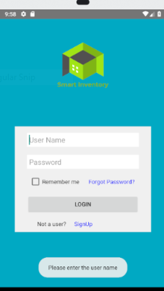 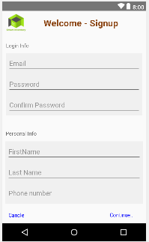

## 3.1.2. Hardware Interfaces

Our Hardware interfaces are any type of smart android devices like Samsung,Motorola,Xiomi etc

Operating system used is Hewlett Packard.

## 3.1.3. Software Interfaces

Android apps can be written using Kotlin, Java, and C++ languages. The Android SDK tools compile your code along with any data and resource files into an APK, an *Android package*, which is an archive file with an .apk suffix.

* The Android operating system is a multi-user Linux system in which each app is a different user.
* By default, the system assigns each app a unique Linux user ID (the ID is used only by the system and is unknown to the app). The system sets permissions for all the files in an app so that only the user ID assigned to that app can access them.
* Each process has its own virtual machine (VM), so an app's code runs in isolation from other apps.
* By default, every app runs in its own Linux process. The Android system starts the process when any of the app's components need to be executed, and then shuts down the process when it's no longer needed or when the system must recover memory for other apps.

## 3.1.4. Communications Interface

Google Docs, sheets and slides:

Google Docs, sheets and slides lends itself to collaborative projects in which multiple authors work together in real time from geographically diverse locations. All participants can see who made specific document changes and when those alterations were done. Because documents are stored online and can also be stored on users' computers, there is no risk of total data loss as a result of a localized catastrophe. However, the Internet-based nature of Google Docs, sheets and slides has given rise to concerns among some authors that their work may not be private or secure.

We use this for creating project documents, sheets and slides for presentation. It is reliable for team-work.

Outlook:

It is Microsoft email service. We use outlook to send and receive mails. Used to contact team members.

## 3.2. Functional Requirements

### Admin Requirements

1. Admin login

Administrator should be able to log in to the system with admin privileges using his admin username and password

|  |  |
| --- | --- |
| Admin username | Any username |
| Password | Minimum of 8 characters  At least one uppercase letter  At least one lowercase letter  At least one number or symbol (!, #, %, &. *) |

2. Add new items to the inventory

Administrator should be able to add new items to the list. Most recently added item should be displayed on the top of the inventory list. New item should have following fields. Items should be able to publish to the user’s list or hide it from the user’s list.

|  |  |  |  |  |  |  |  |  |
| --- | --- | --- | --- | --- | --- | --- | --- | --- |
| ID | Picture of the item | Item | Description | Buying price | # of units needed | Added date | Expiring Date | Comments |

3. Edit/Remove items on the inventory

Administrator should be able to edit or remove any existing items on the list. When editing, he can edit all the fields except ID.

4. Accept or deny membership requests from new users

When a new user wanted to sign up for the Smart Inventory, he may fill up a sign up form and send the request to the vendor. Vendor should be able to accept or deny the request and send an email to the user informing the decision.

5. Accept or deny items supply requests from users

Once a user submit an item supply request, vendor should be able to accept or deny the request and inform the user the decision through an email.

6. Admin should be able to send shipping labels to the user

If vendor accept the item supply request, he should send shipping label to the user’s email for the accepted items.

7. Conform the received items from the users

Once vendor received the items form a user, vendor should be able to conform the received items and send a request for invoice from the user. These information will be sent to the user’s email.

8. Accept and pay user bills

Once user send the invoice for the items, vendor will pay the user through a third party money transfer system.

### User Requirements

1. Make request for sign up

When a potential user wanted to be a member of the smart inventory system, he should fill the sign up form and send it to the vendor for approval. When a user sign up for the system, he should provide following details.

|  |  |  |  |  |  |  |  |  |
| --- | --- | --- | --- | --- | --- | --- | --- | --- |
| First Name | Last Name | Email Address | Password | Contact number | Date of birth | Gender | Selected security question | Security answer |

In addition he needs to agree to the user agreement and user privacy notice

2. Log in to the Smart Inventory - Android

Once vendor approves the signup request, user can log in to the Smart Inventory – Android using his email address and password.

3. Recover lost or forgotten password

If user lost or forgot the password, he can recover the password by answering to the security question. The new password will be sent to the user’s email.

4. View the items and details vender looking for

Once the user log in to the Smart Inventory – Android, he can view the list of items currently vender is looking for. In the initial list it will display the following fields

|  |  |  |  |  |  |
| --- | --- | --- | --- | --- | --- |
| ID | Picture of the item | Item | Buying Price | # of units needed | Expiring date |

If user wants to see more details about a specific item, he can tap on the item and view the other information and methods of supplying the items.

5. Send requests to vendor for supplying items and request shipping labels

If user wish to supply any items to the vendor he can fill an item supply request and send it to the vendor for acceptance. In that request user need to provide the following details.

|  |  |
| --- | --- |
| Number of items | If shipping label required |

6. Send requests for canceling/editing supplying list

If user wants to cancel or change a supply request that sent to the vendor, he should be able to send a cancel/change supply request to the vendor.

7. Send invoice to vendor for payments

Once user receive the item received confirmation from the vendor, user can send an invoice to vendor for payments. In this invoice, user should provide the available methods for receiving money from the vendor.

8. View the user’s transaction history

User should be able to view his transaction history with vendor

9. Logout

## 3.3. Use Cases

A use case is a methodology used in system analysis to identify, clarify, and organize system requirements. The use case is made up of a set of possible sequences of interactions between systems and users in a particular environment and related to a particular goal. A use case can be thought of as a collection of possible scenarios related to a particular goal, indeed, the use case and goal are sometimes considered to be synonymous.

A use case (or set of use cases) has these characteristics:

· Organizes functional requirements

· Models the goals of system/actor (user) interactions

· Records paths (called *scenarios*) from trigger events to goals

· Describes one main flow of events (also called a basic course of action), and possibly other ones, called *exceptional* flows of events (also called alternate courses of action)

· Is multi-level, so that one use case can use the functionality of another one.

## 3.4 Non-Functional Requirements

### 3.5.1. Performance

### 3.5.2. Reliability

3.5.3 Availability

3.5.4 Security

3.5.5 Portability

` 3.5.6 Constraints

4. Design

## 4.1 ER diagram

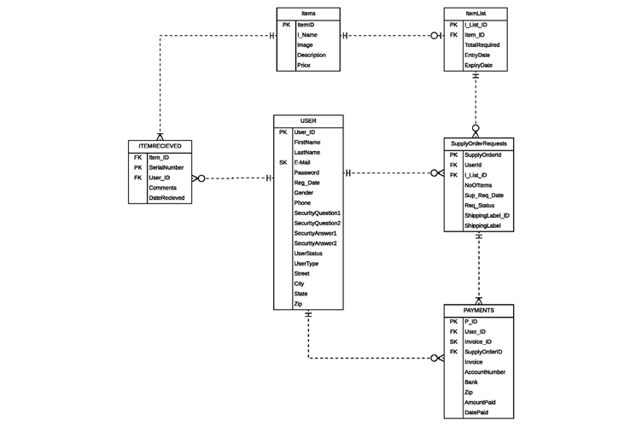

## 

## 4.2 GUI

|  |  |
| --- | --- |
| Login Page | Password Recovery |
|  |  |
| Signup | Signup2- SecQuestions |
|  |  |
| User Home | Item Details |
|  |  |
| Admin View | Add Item |
|  |  |
| New user request | New user accept |
|  |  |

**5.** **Analysis Models**

## 5.1 Gantt Chart

Please refer to the support document Gantt Chart PDF and Gantt Chart MPP.

Smart Inventory - Android App

Version 2.0.0

# Technical Manual

Team : Android Team

Course: 44691-1

Class : GDP 02 Spring 2018

TEAM MEMBERS  
Rakesh Varma Nadakudhiti  
Snohitha Rakashi  
Lokeswari Pittu  
Nilantha Dambadeni Kalu Achchillage  
Shivani Busireddy  
Niharika Gundala

Karthik Raja Vemula

# Table of Contents

**1 Introduction** **20**

1.1. Document Identification 20

1.2. System overview 20

1.3. Tools and technologies 20

1.3.1. Android Studio 3.2.1 20

1.3.2 Firebase 20

1.3..3 GitHub 20

1.4 Document overview 21

**2. Client Signup** **22**

2.1. Requirement 22

2.2 Technical information 22

# 1 Introduction

## 1.1. Document Identification

This document describe the technical aspect of design and implementation of SmartInventory App for android based mobile phone. This document is prepared by Android team of GDP 01 (44691-1) Fall 2018.

## 1.2. System overview

SmartInventory-Android is developed for android base mobile devices to make it possible for clients to communicate with the vendor for supplying vender required items. This app is consist of two parts as client application and admin application. Clients can download the client application through internet and use it to communicate with the vendor and supply items for vendor. Admin application can be used by vendor and it is not distributed through the internet. Admin application can be used to reply to client requests, add items, upload shipping labels and other administrative tasks.

## 1.3. Tools and technologies

### 1.3.1. Android Studio 3.2.1

Android Studio 3.2.1 is used to develop the User Interfaces (UIs) -Activities, and frontend and backend functionalities.

### 1.3.2 Firebase

Google Firebase is used for backend data handling, storing and manipulation. Also Authentication, Email verification and password recovery functionalities are implemented using firebase functionalities.

Firebase Account Credentials

User Name : [gdpsmartinvntory@gmail.com](mailto:gdpsmartinvntory@gmail.com)

Password : SmartInventory123

### 1.3..3 GitHub

Github repository is used for version control and collaborating purpose of the development process. All the implementation and documentation work were uploaded to the github by each member of the team as they work.

Github link : https://github.com/NilanthaD/SmartInventory_Android.git

### 1.4 Document overview

This document will describe the technical aspect of each activity, functionality and associations separately. The list and order of the items will be as follows.

1. Sign Up for user
2. Login for user
3. Password recovery for user
4. User logout

Documentation will be continued as the functionalities are implemented….

# 2. Client Signup

## 2.1. Requirement

Once the user download the app, he can see the signup option on the login window. Once he click on the signup option, he will directed to the signup page. Then user can provide the necessary information and sign up for the app. Then the user will get a verification email to his email account and he must verify his email in order to get access to the app.

## 2.2 Technical information

i. App is connected to the Firebase and activated the Authentication with email and password authentication.

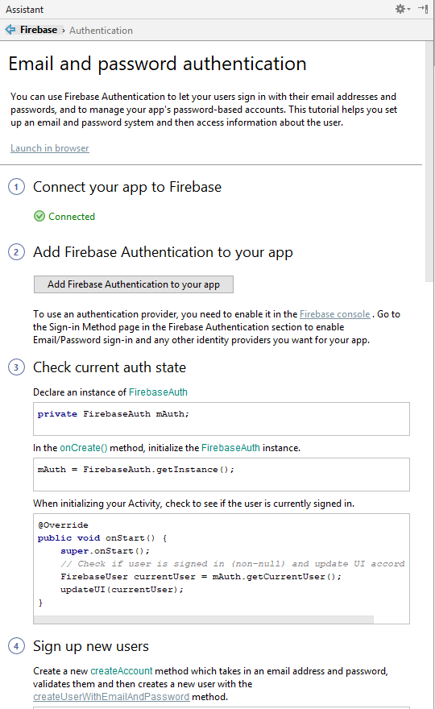

ii. Signup activity is created on Android studio

 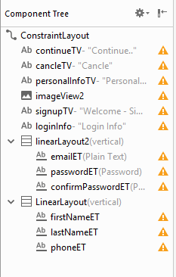

iii. User need to fill all the information on signup page, otherwise it will pop up a warning dialog asking to fill all the information.

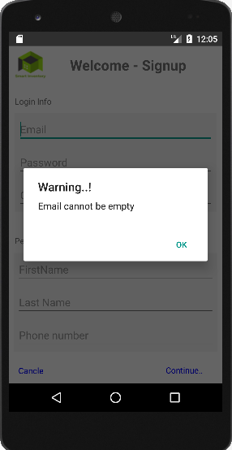 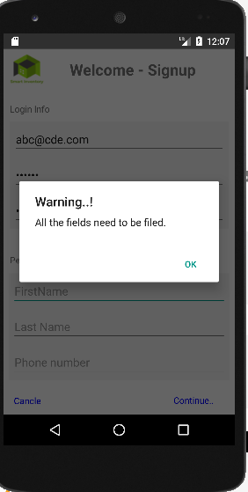

iv. Once user fill all the information and click on continue, it will create a new intent with all the user information and go to the Security Questions activity.

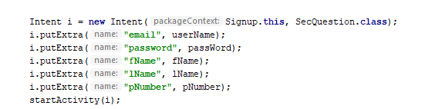

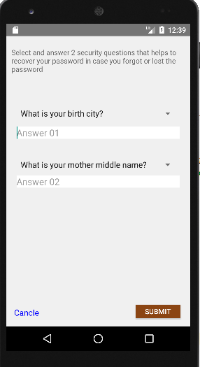

v. Once user anwer the both selected security questions, and click submit button, it will create a record on the firebase authentication and will send an email to the user for verification.

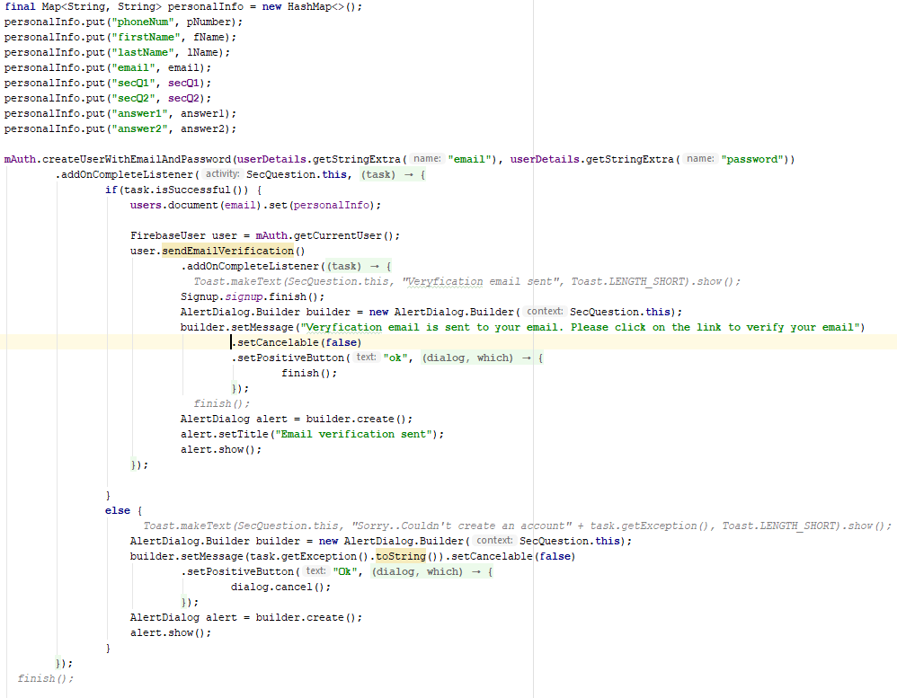

vi. Authentication data will store in the firebase authentication and personal data will store on firebase firesotre.

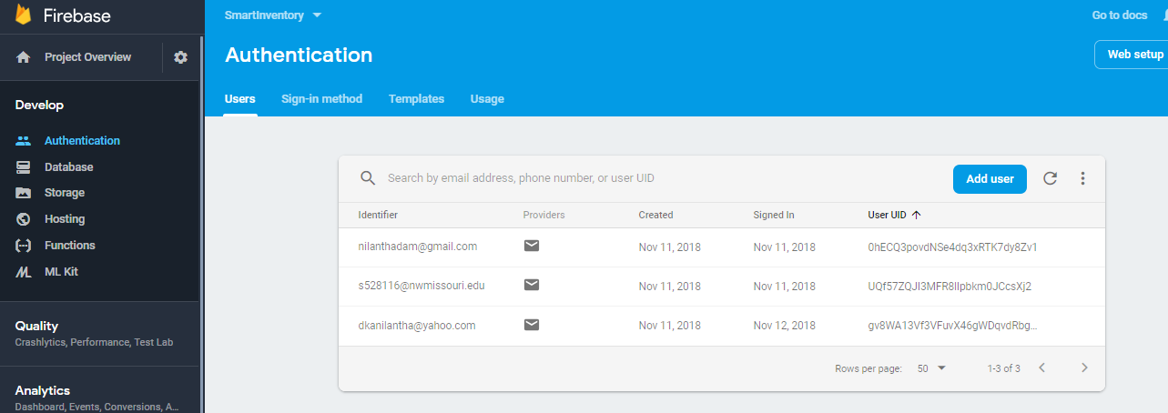

In firestore, user details will store as follows.

Here document id would be the user’s email address.

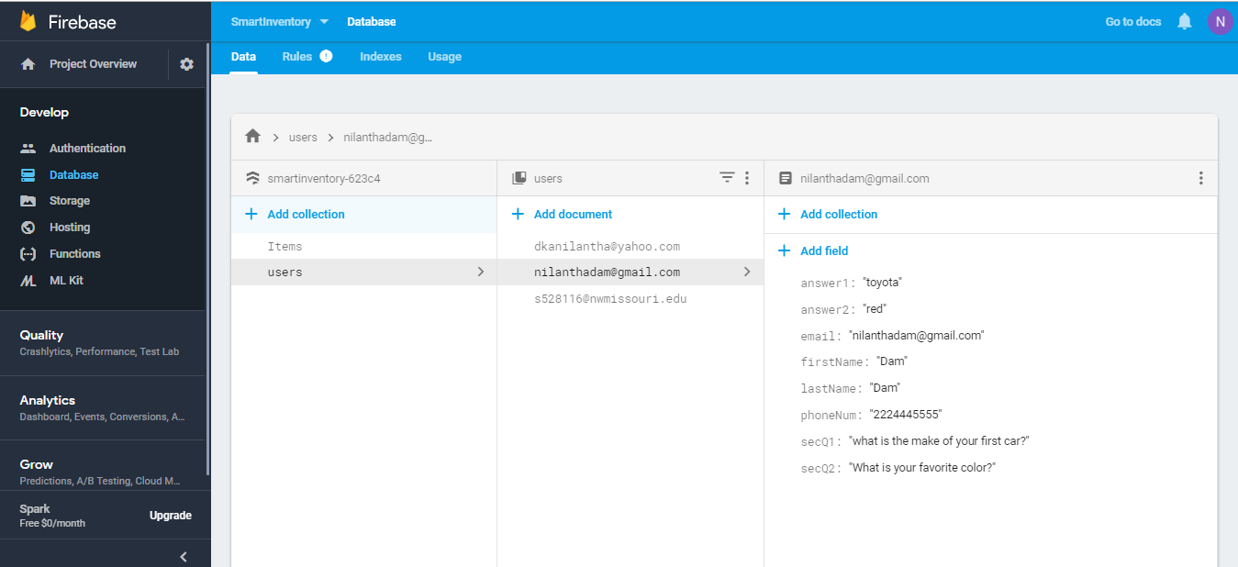

vii. At any time, if user click the cancel button, it will close all the activities except the login (main) activity.

3. Client Login

If the user haven’t entered username or password, it will display the message in toast.

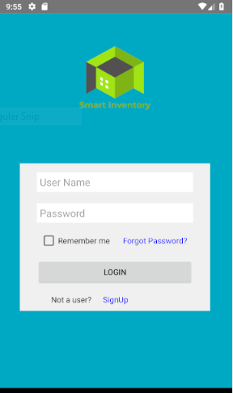



Login Functionality:

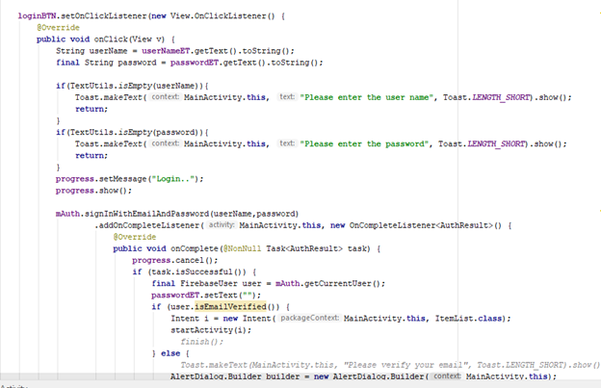

**ItemList Functionality:**

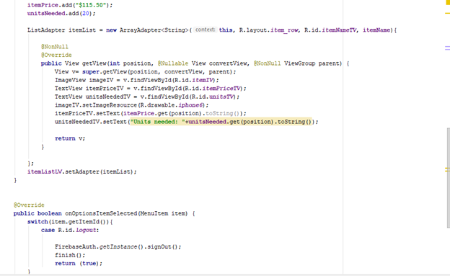

Password Recovery for User:

If the user forgets his/her password, he can request for the change of password using forgot password option.

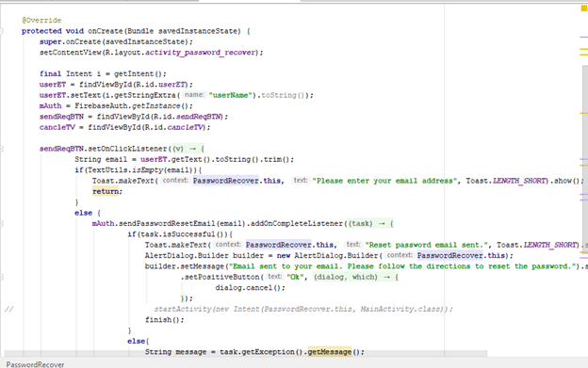

**Password Recovery Functionality:**

**About US:**

Phone View:

In about us page the user can know everything about the app.

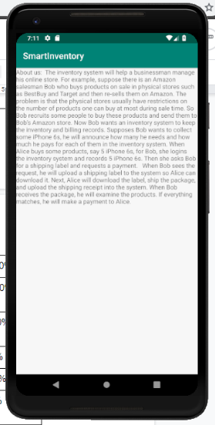

About Us functionality:

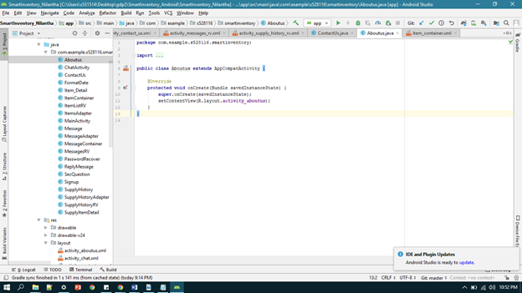

XML functionality:

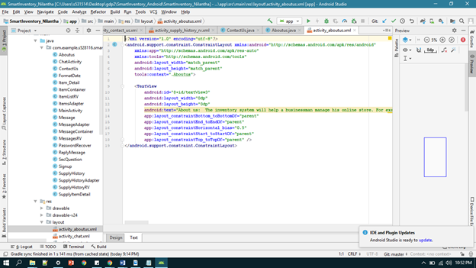

Contact Us:

Contact Us is a page where user can interact with the people of the app, they can clarify their doubts or any other required question.

Phone view:

The user can send the question regarding the app, by using the contact page.

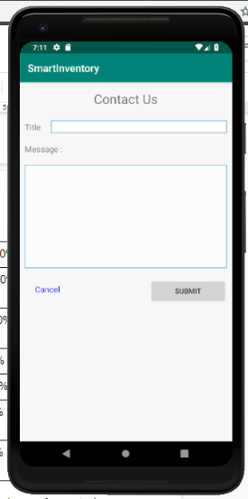

Contact us functionality:

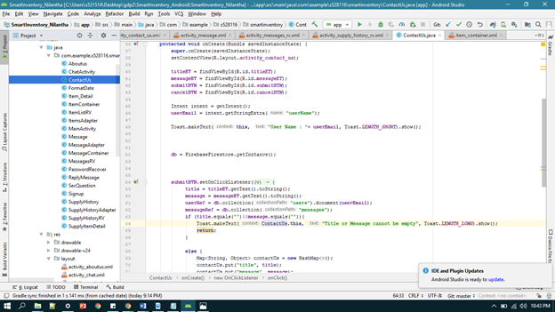

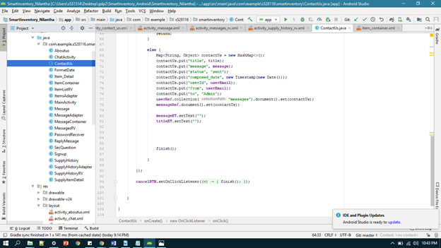

XML functionality:

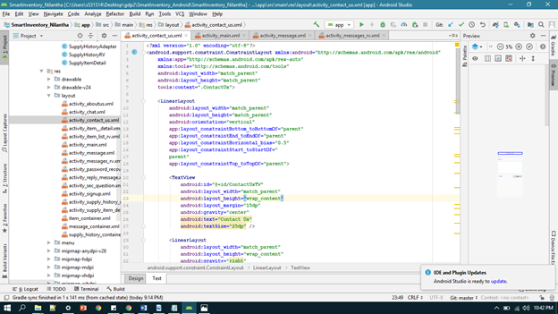

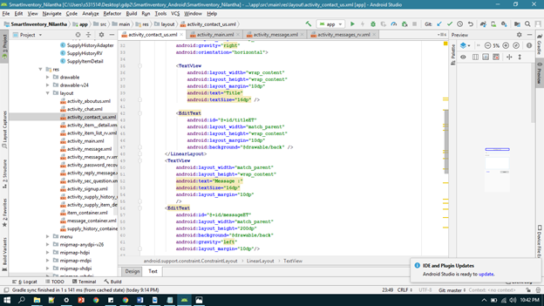

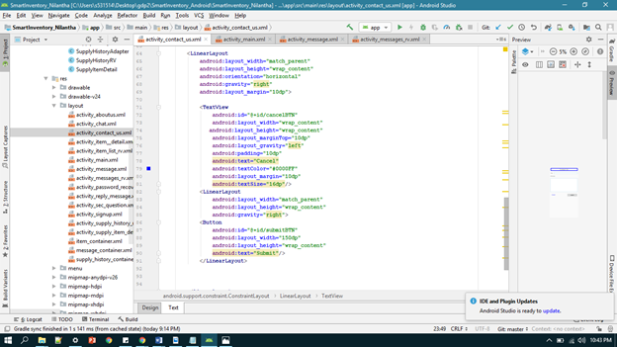

Chat Activity:

The user Can chat with the admin online while purchasing any item. He can ask the doubts regarding the item.

Code Functionality:

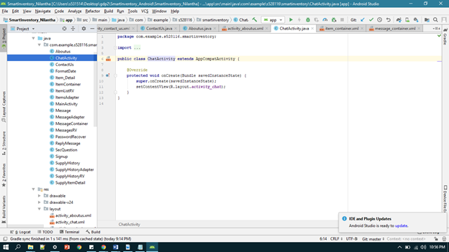

XML Functionality: 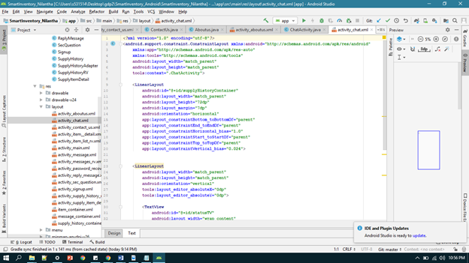

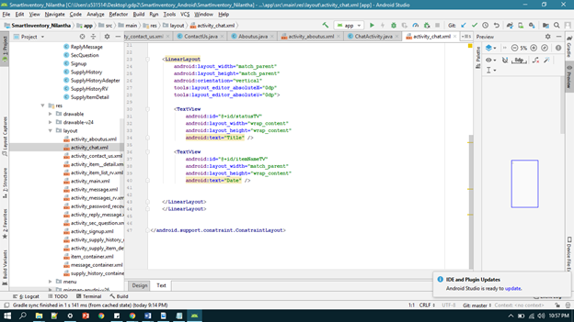

Item Detail:

In this page the list of all the items is displayed.

Phone View:

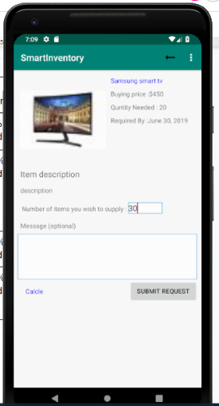

Code Functionality: 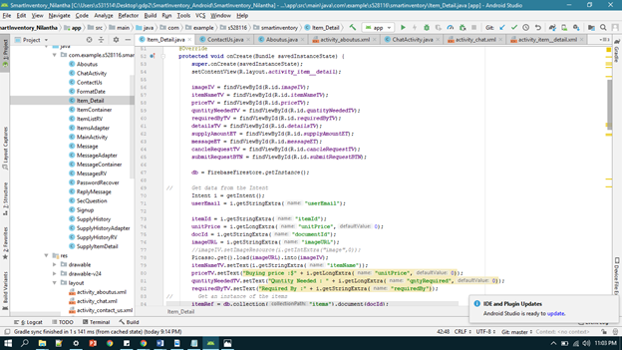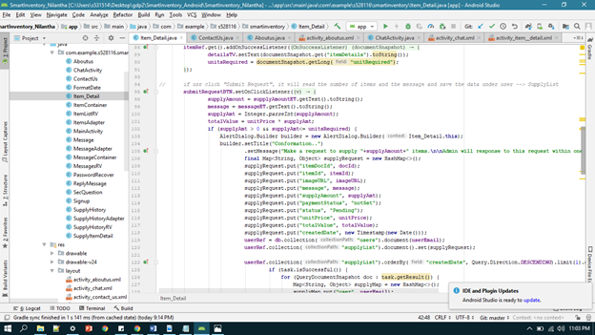

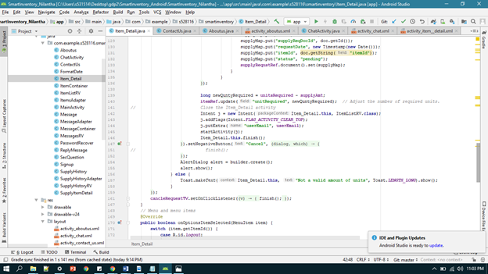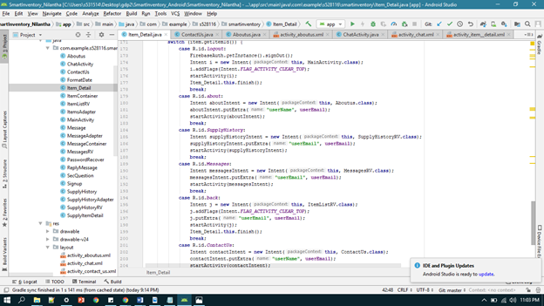

XML functionality: 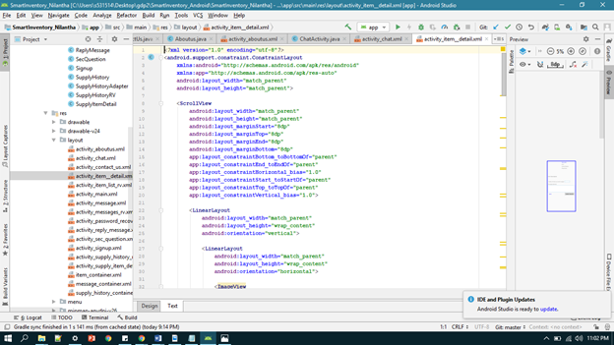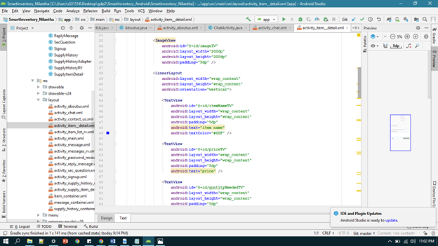

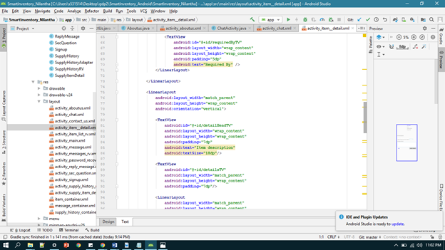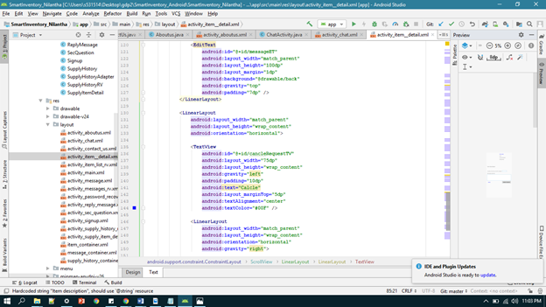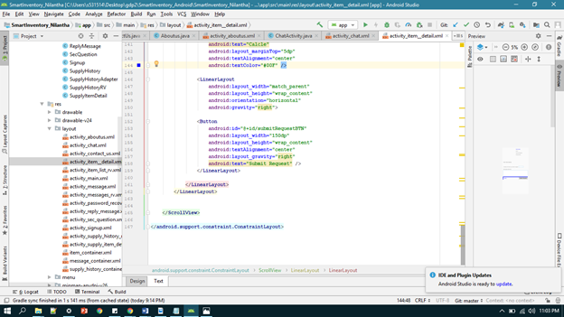

Item Container:

Phone view:

Code Functionality:

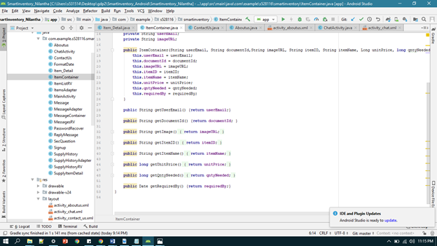

XML Functionality: 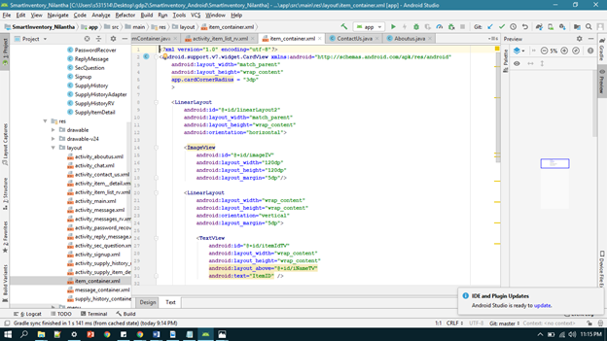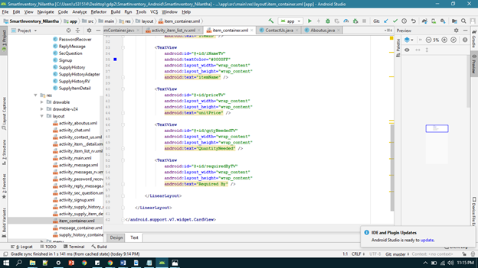

List of Items:

Phone View:

Code Functionality: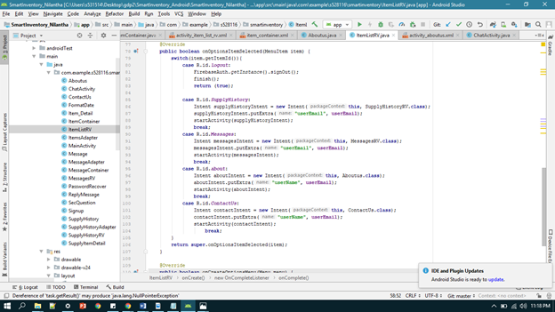

XML Functionality: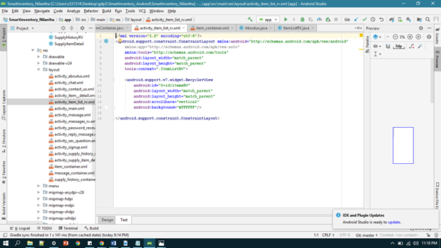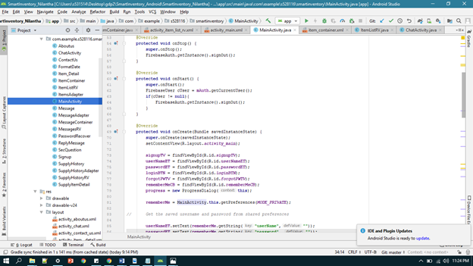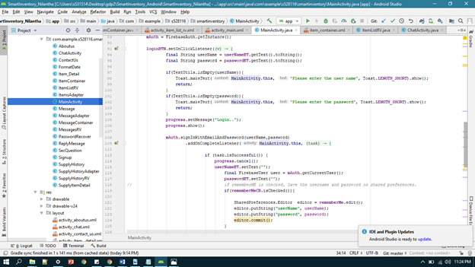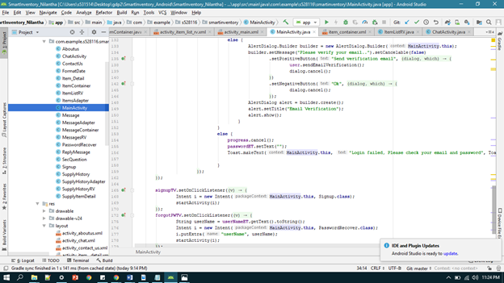

Main Activity:

Phone View:

Code Functionality:

Xml Functionality:

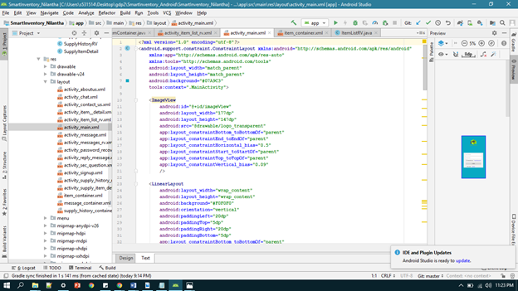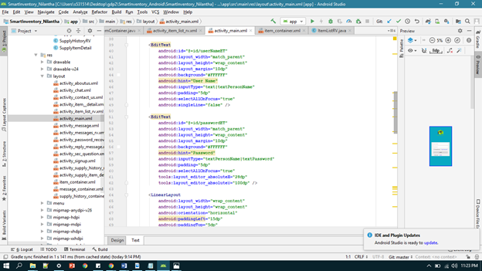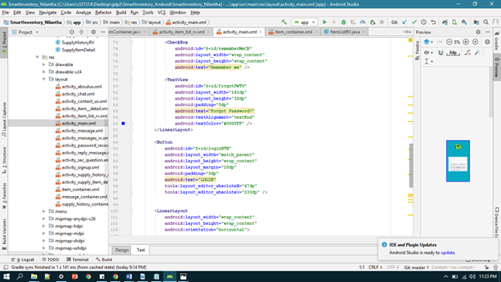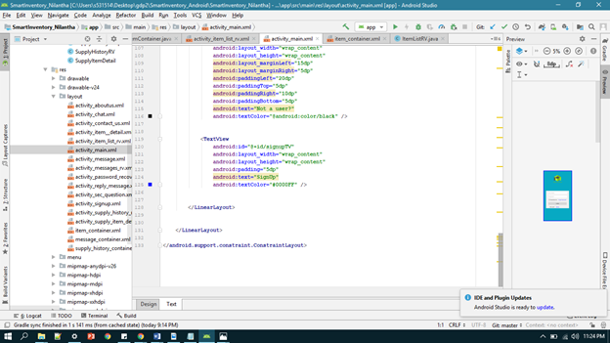

Supply History:

Phone View:

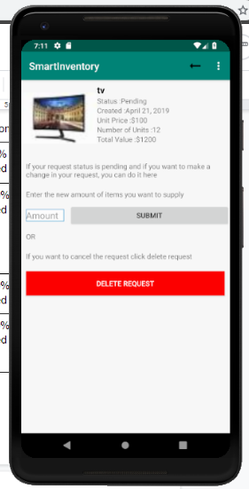

Code Functionality: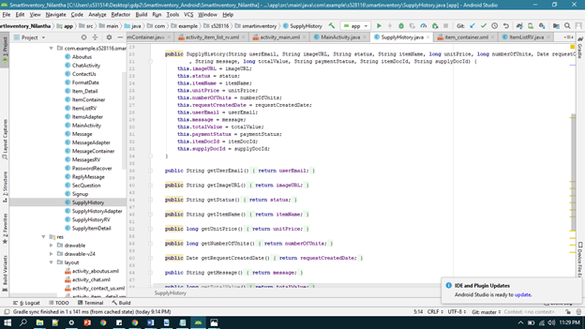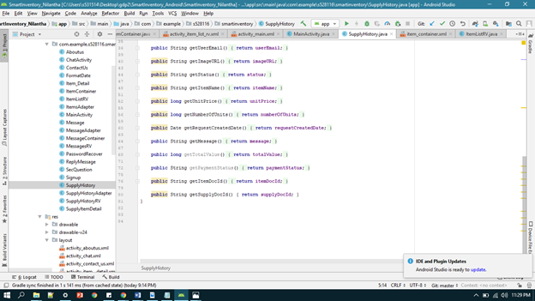

XML Functionality: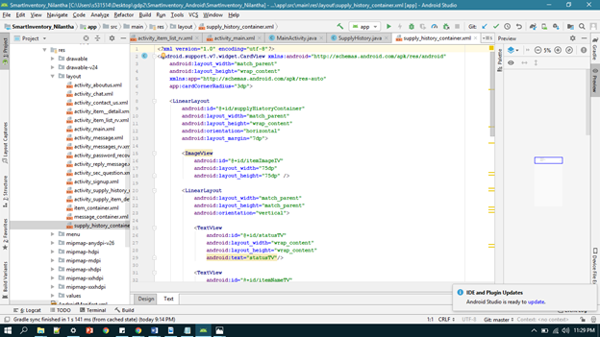

Supply Item:

Phone View:

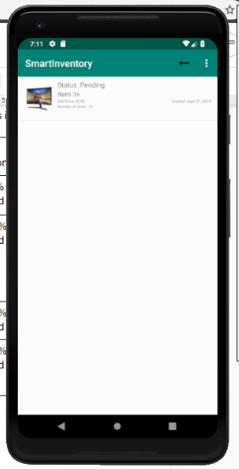

Code Functionality:

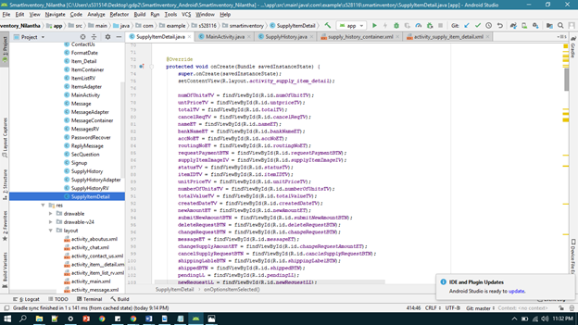

XML Functionality: 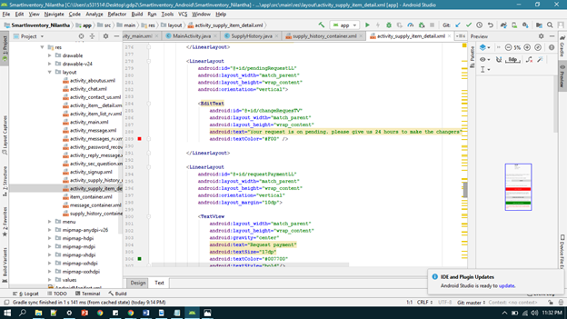

Smart Inventory - Android App

Version 2.0.0

# **Technical Manual-Admin**

Client’s Admin Manual

Team : Android Team

Course: 44691-1

Class : GDP 02 Spring 2019

TEAM MEMBERS

Rakesh Varma Nadakudhiti

Snohitha Rakashi

Lokeswari Pittu

Nilantha Dambadeni Kalu Achchillage

Shivani Busireddy

Niharika Gundala

Karthik Raja Vemula

**Admin user interface and Signup functionality:**

**Admin can sign up by filling out all the fields and then he/she can log in when ever he wish to. Below are two views of login and sign up functionality.**

**Phone Views:**

**Login view and SignUp view:**

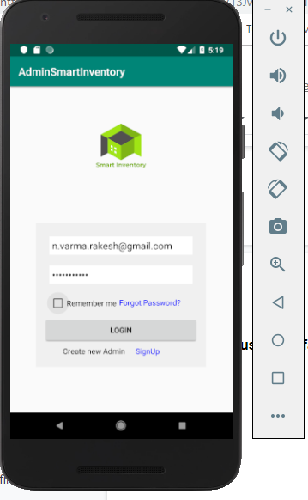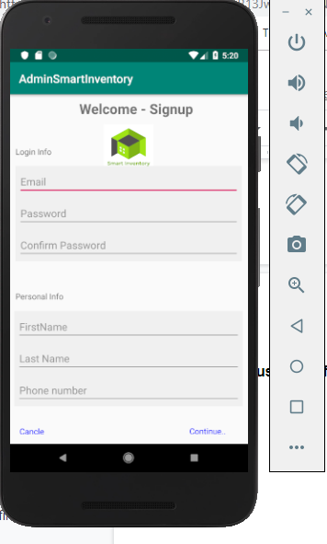

**Java classes for Login and Signup:**

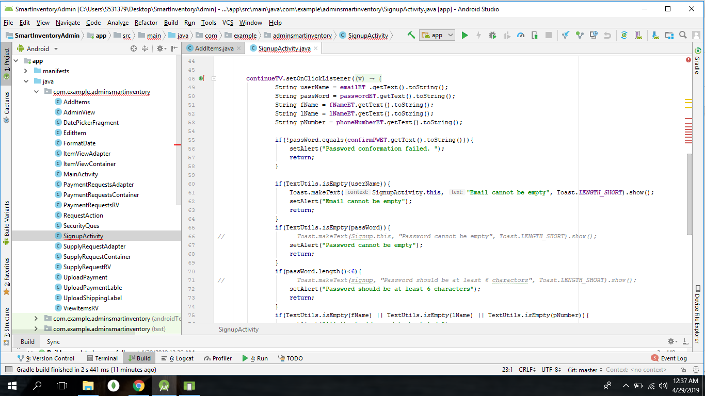

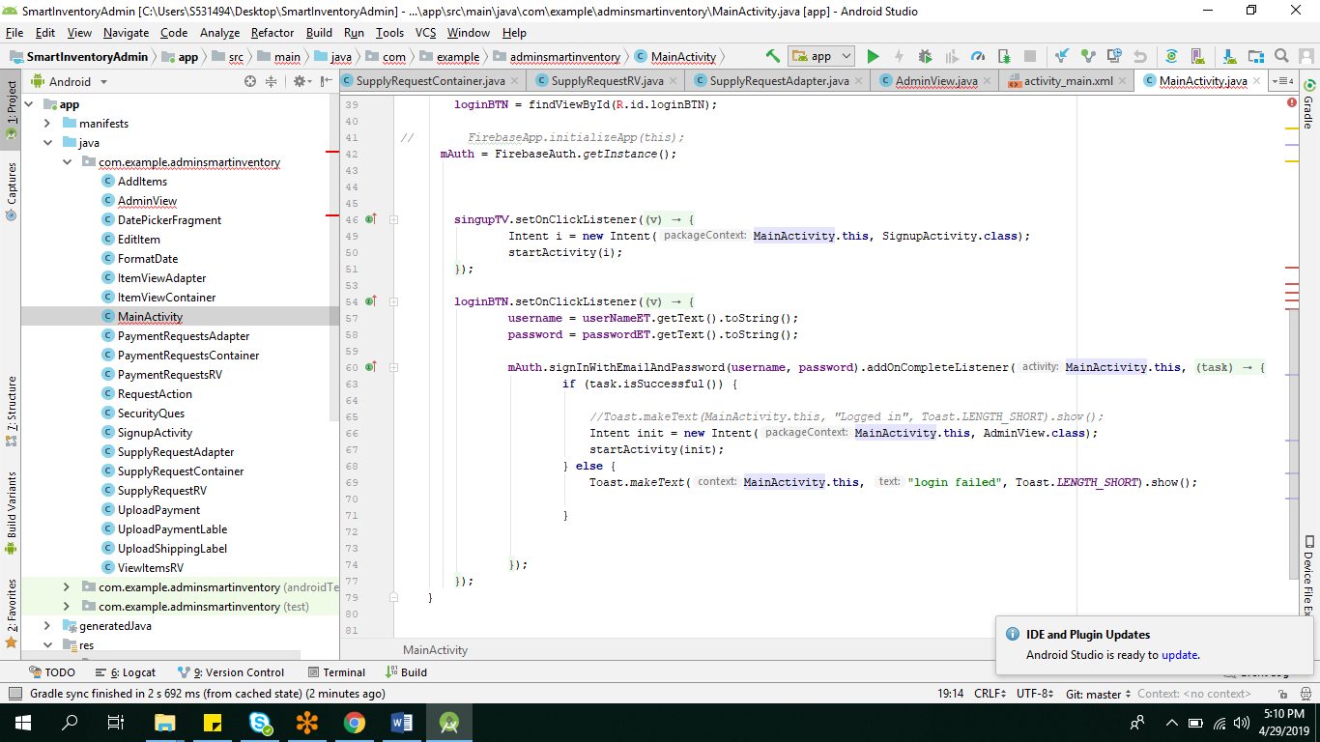

**Xml Activities for Login and SignUp functionalities:**

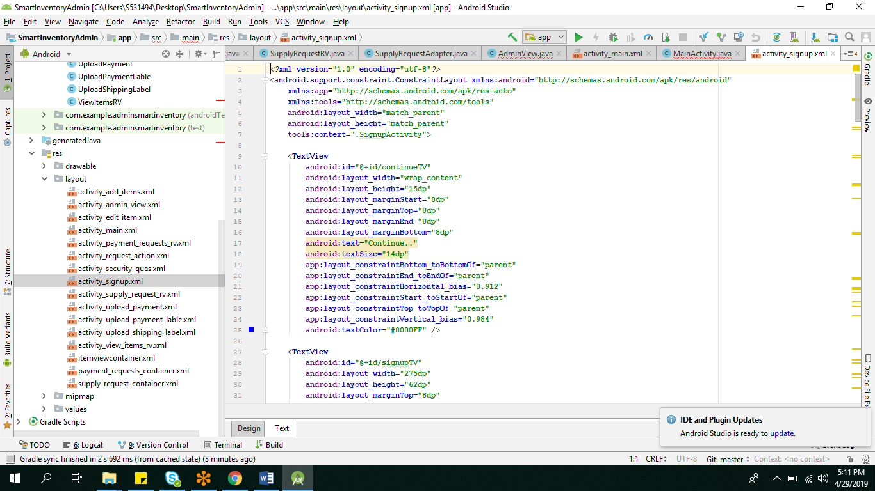

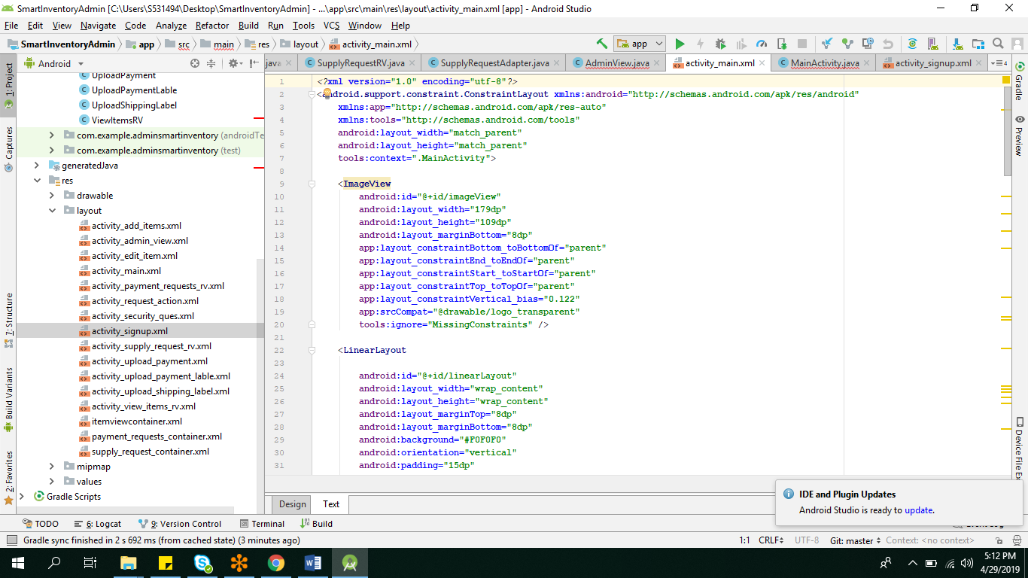

**Admin View:**

**This is how the first page looks when admin log in to the App.He/she can Add items,View/Edit the requests which he has posted,can view all the supply requests, make payment request and can even reply for the messages.**

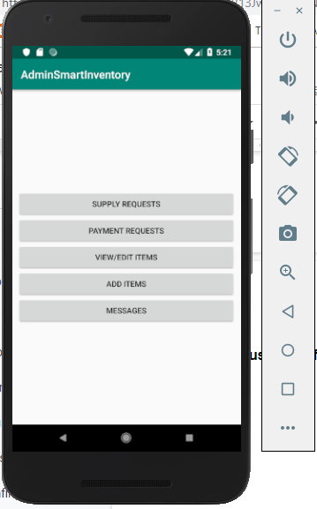

**Admin View Java Class:**

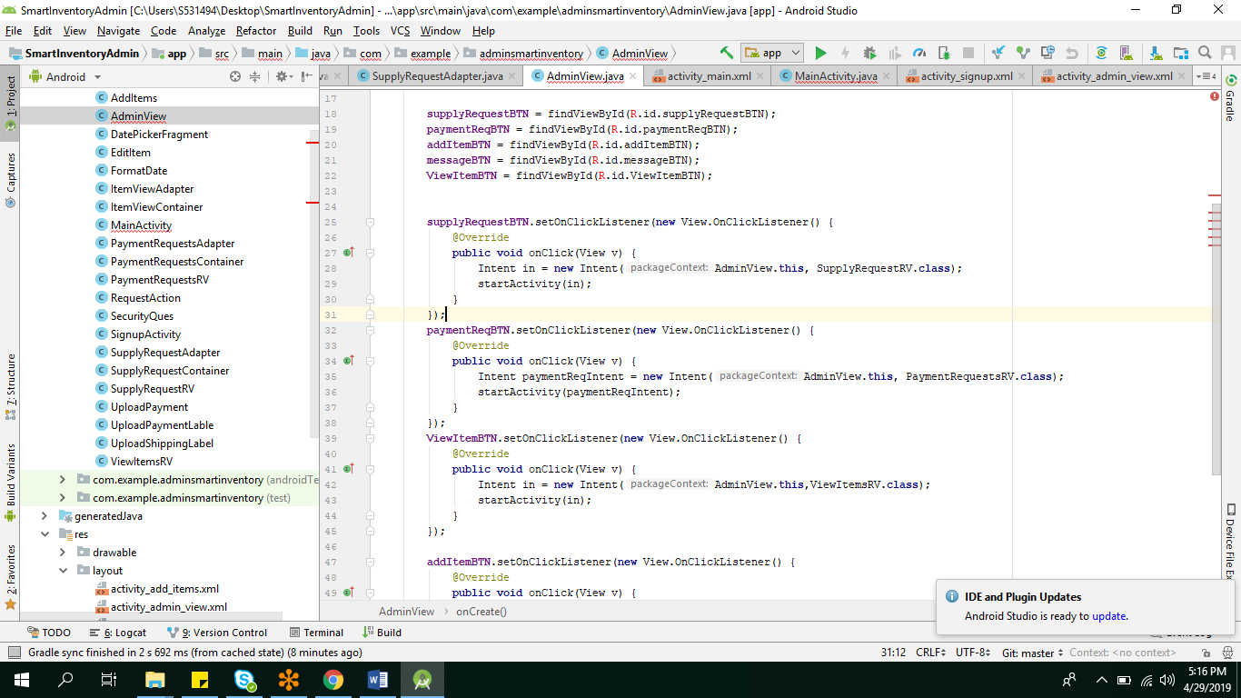

**Admin View Xml Functionality:**

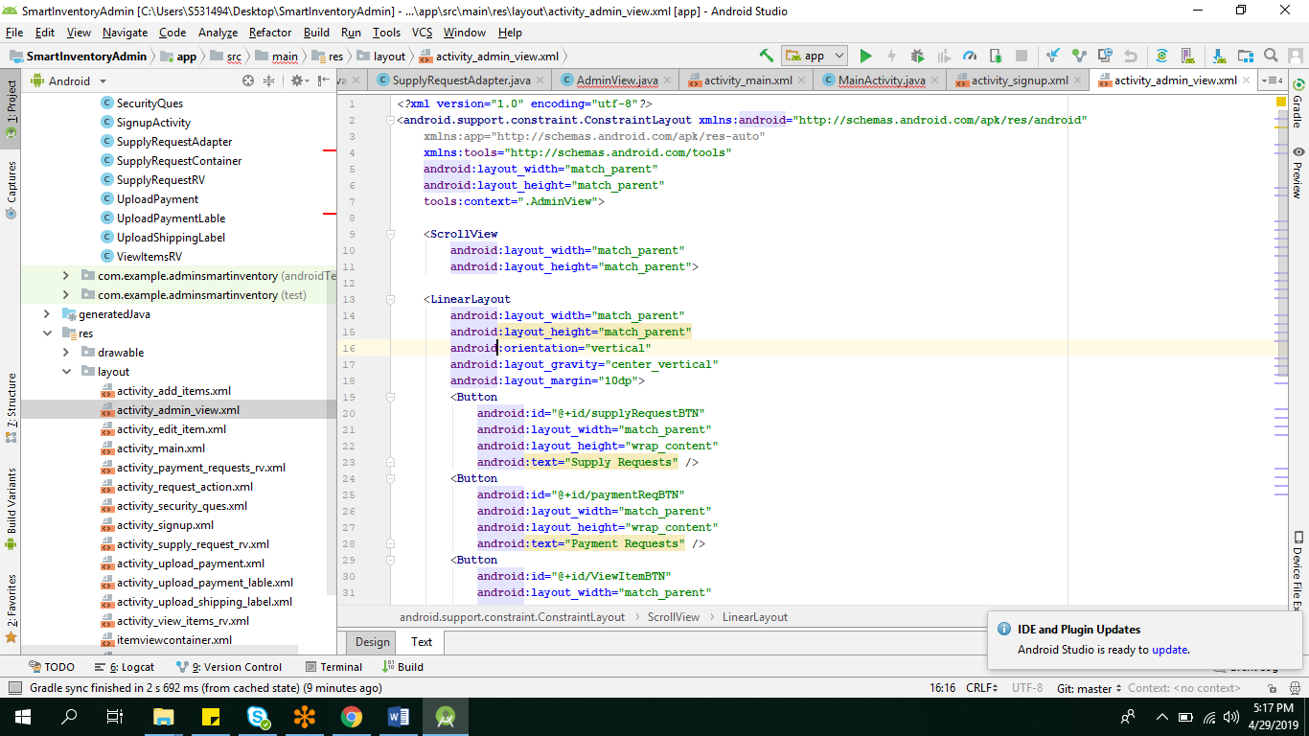

**Supply Request Page:**

**Admin can view all the supply requests from the vendors.The supply requests can be approved,denied or modified by the Admin.There are three activities for the supply request page.**

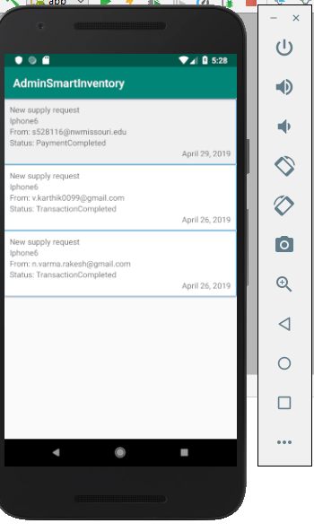

**In the below two views, we can see the dropdown where admin can approve or deny the supply requests and make save changes to make those changes reflected.**

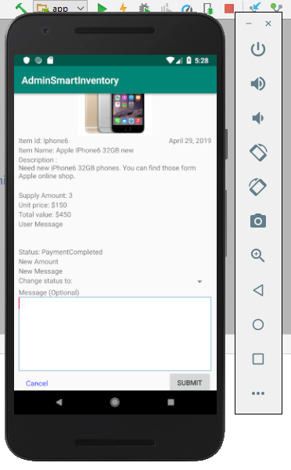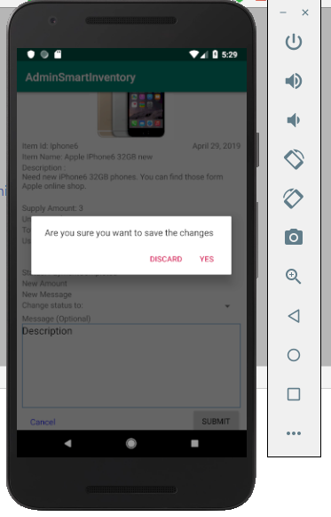

**In the below view,user has completed the transaction and the view of the supply request is shown:**

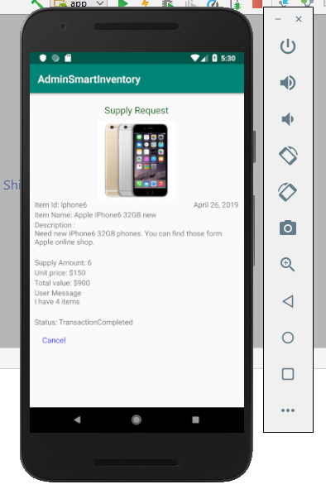

**Java classes for the above supply requests:**

**Supply Request Rv and Supply Request Container and Supply Request Adapter.**

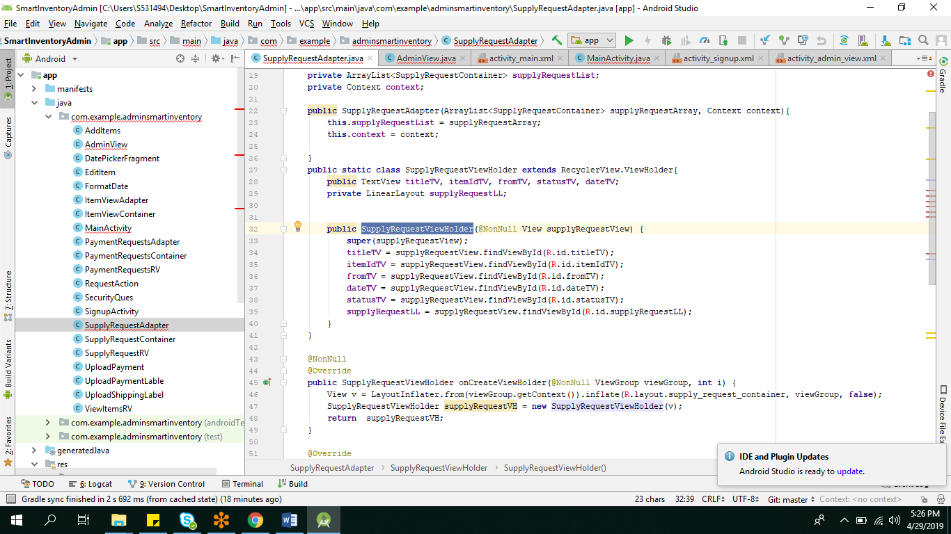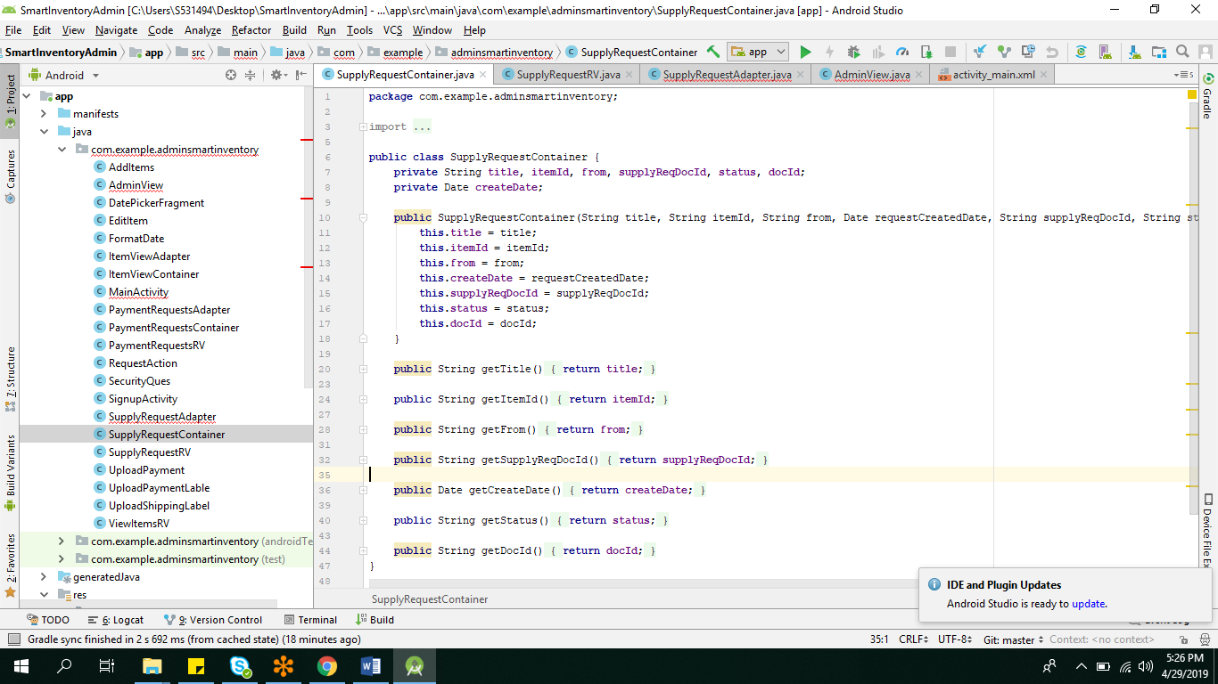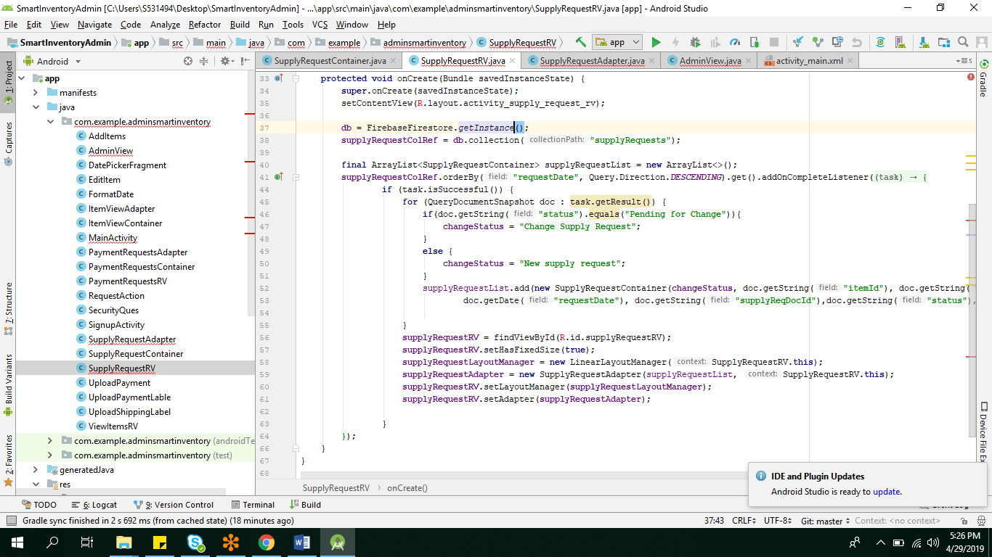

**Xml Functionalities for the above classes:**

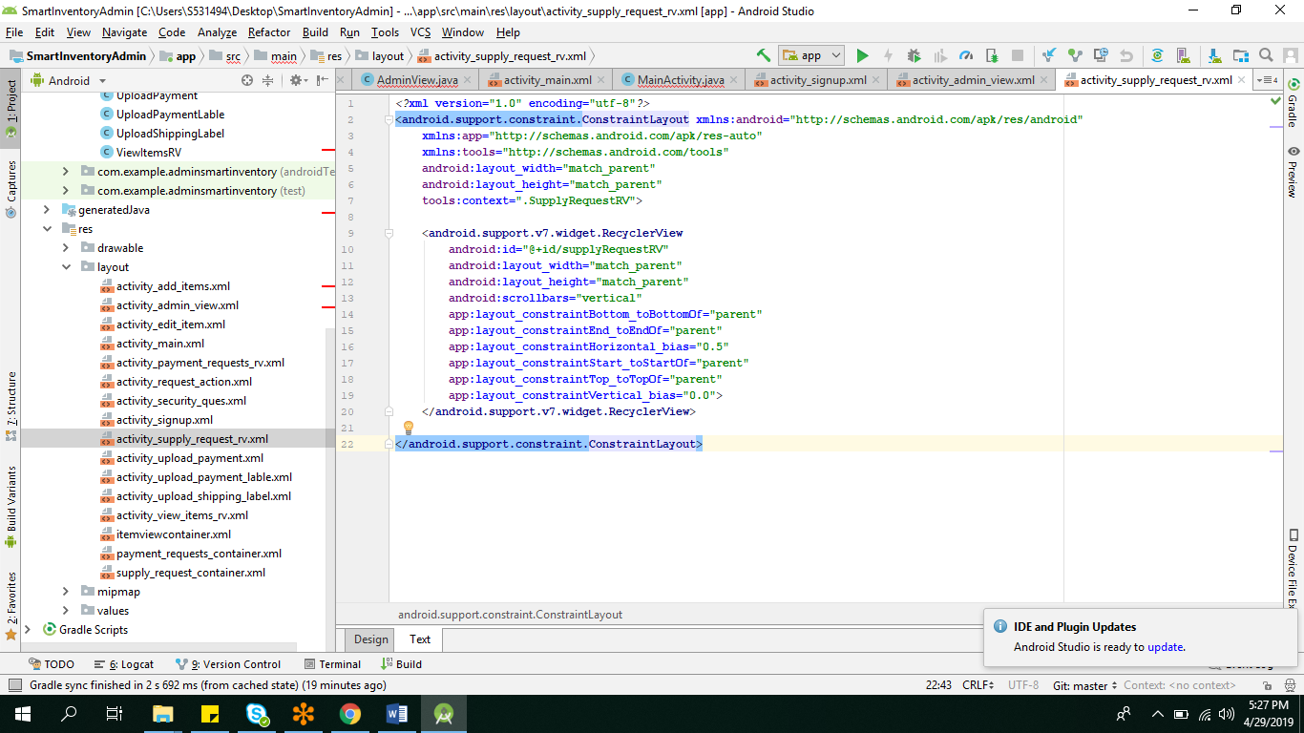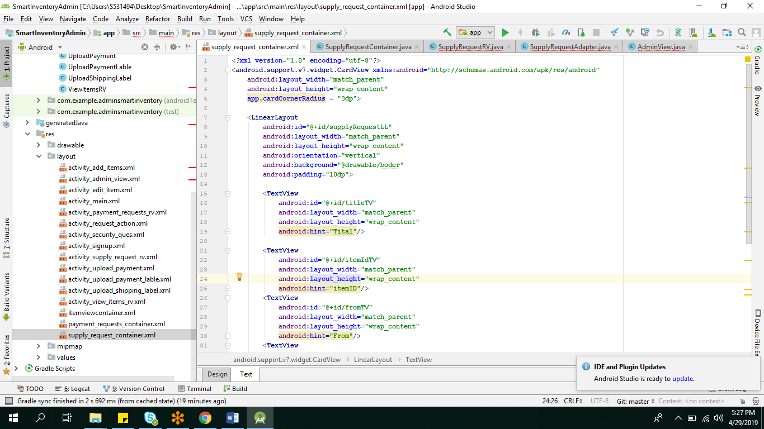

**Upload Shipping label:**

**Admin can upload the shipping label and user can download it and then payment request is done.**

**Java class for uploading shipping label:**

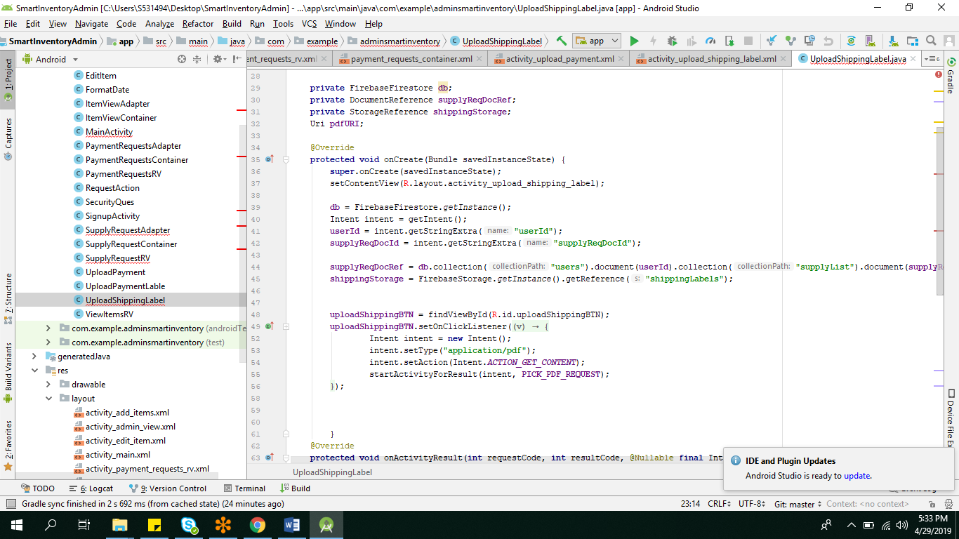

**Xml Functionality for uploading shipping label:**

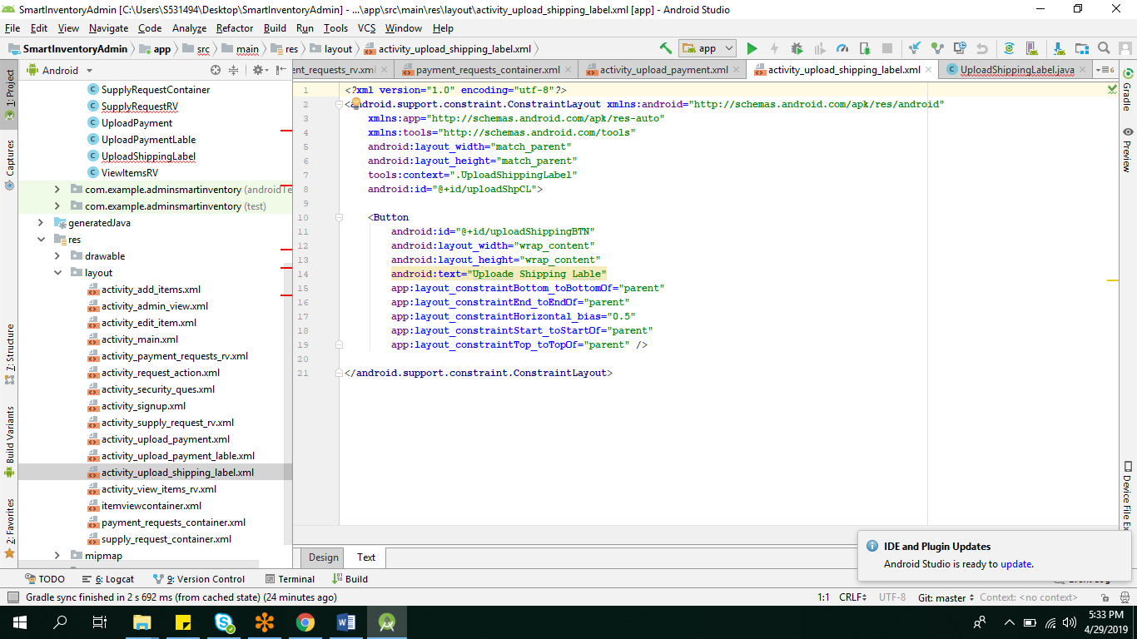

**Payment Requests:**

**Admin can send the payment for the shipping label sent, so he will be requesting the vendors bank details.After bank details are sent from the Vendor, Admin make the payment and Upload the Payment receipt.**

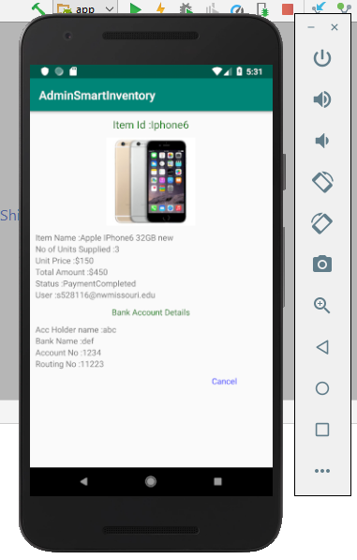

**Java classes for all the functions described above:**

**PaymentRequestRV,PaymentRequestContainer,PaymentRequestAdapter, UploadPayement, UploadPaymentLabel are the classes below:**

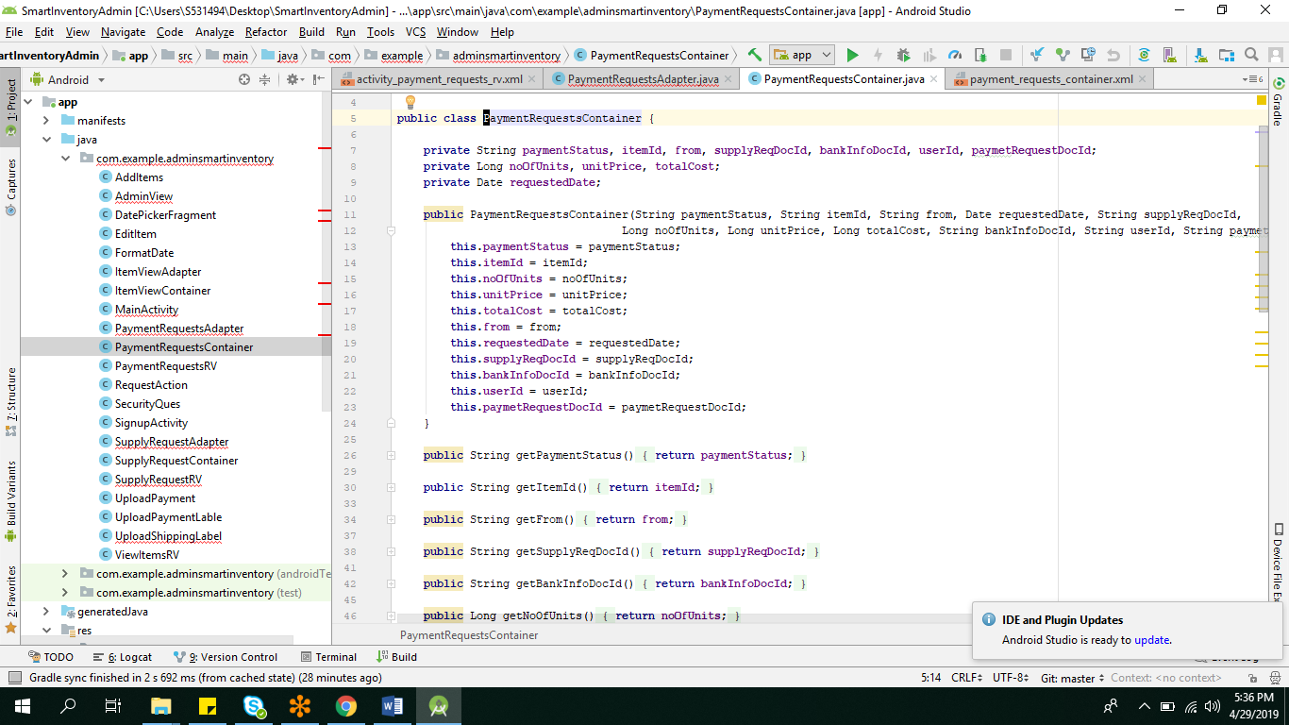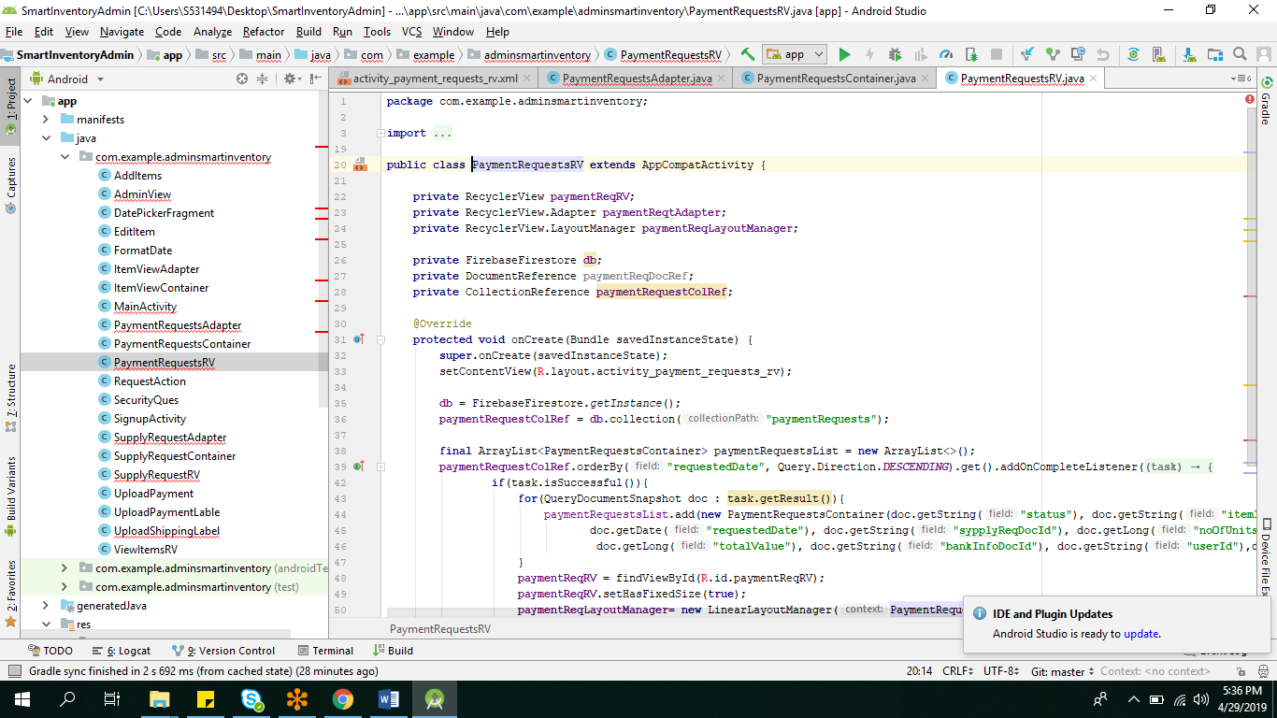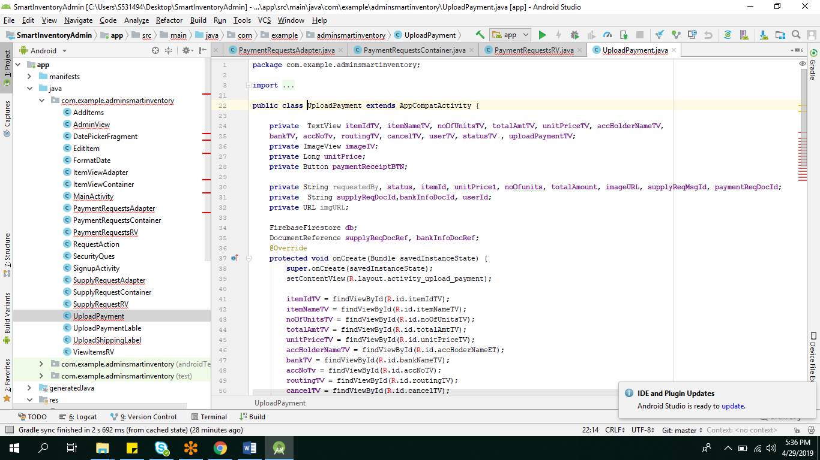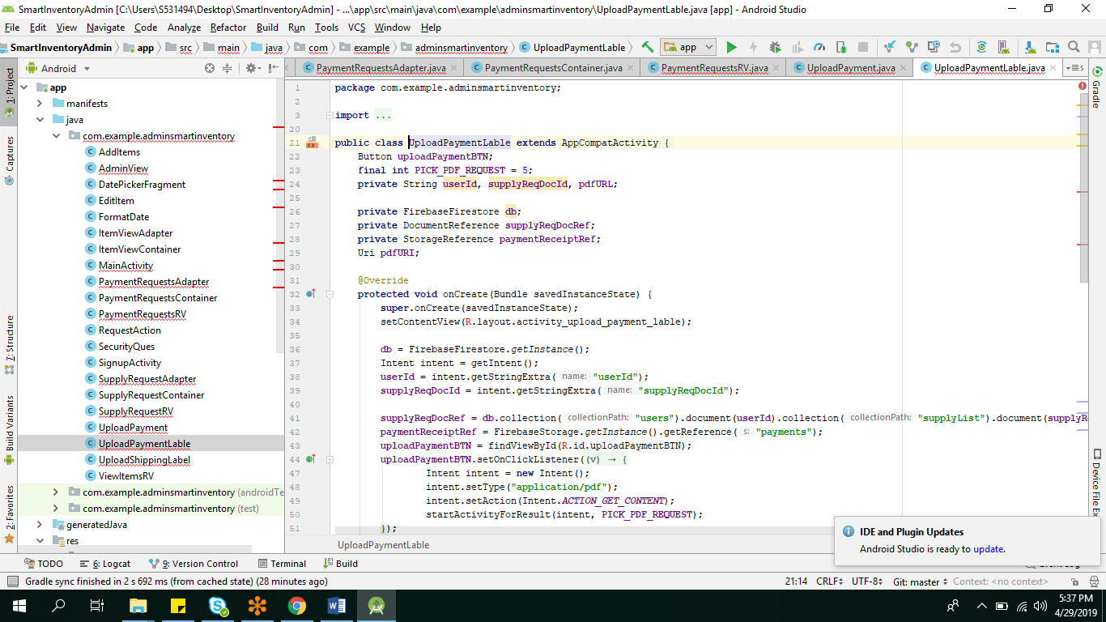

**Xml Functionalities for the above classes:**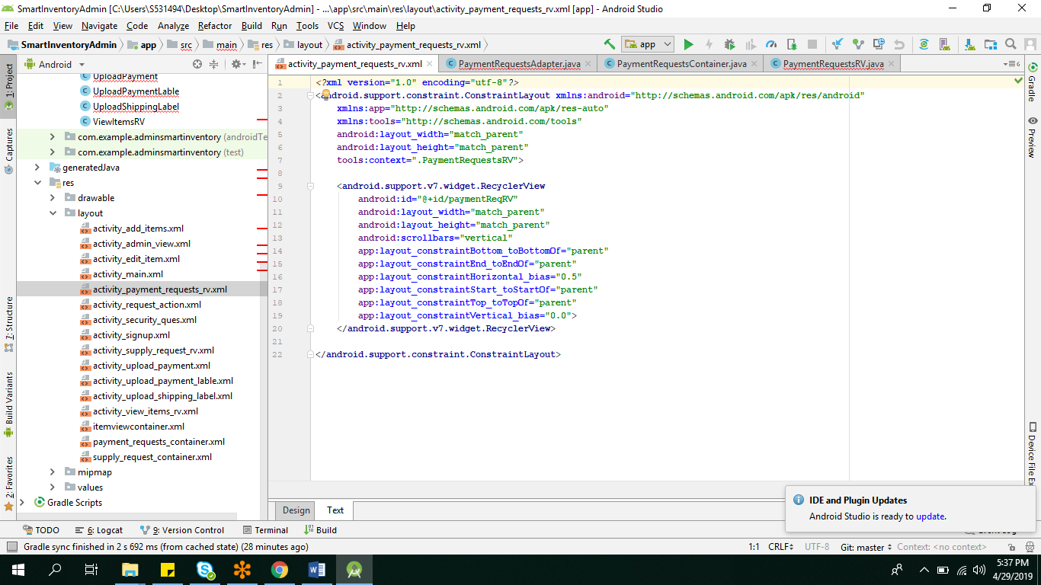

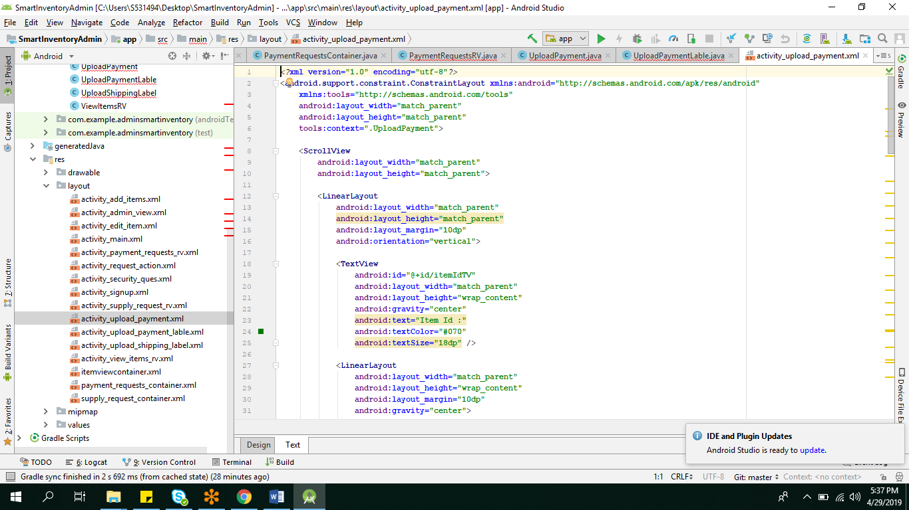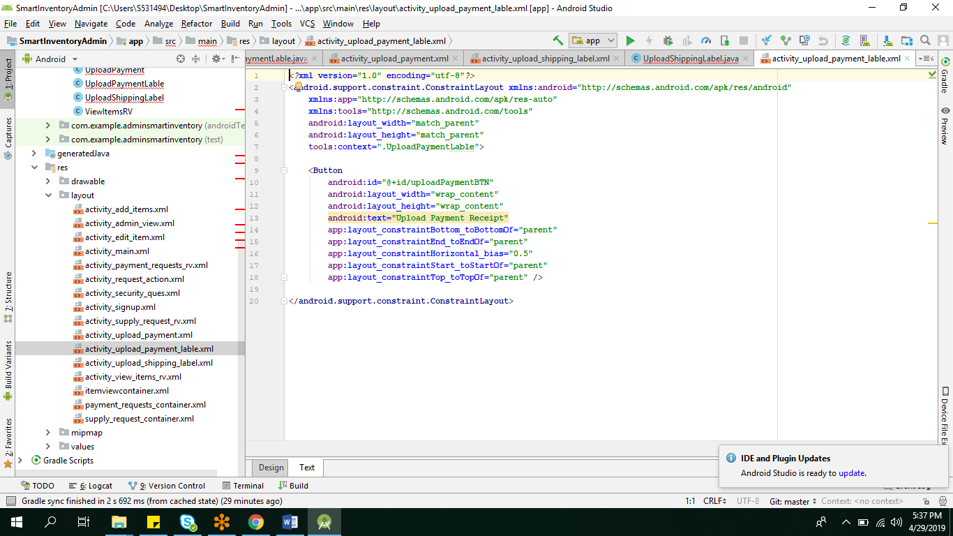

**View/Edit Item:**

**Admin can view or edit the announcement made by him/her.Admin can change the expiration date,Amount he needed,Buying price and even change the description of the item.**

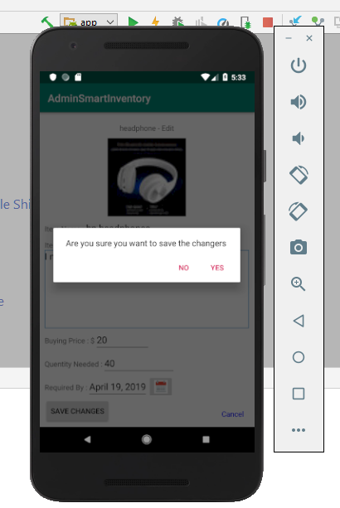

**Java classes for view/edit the item:**

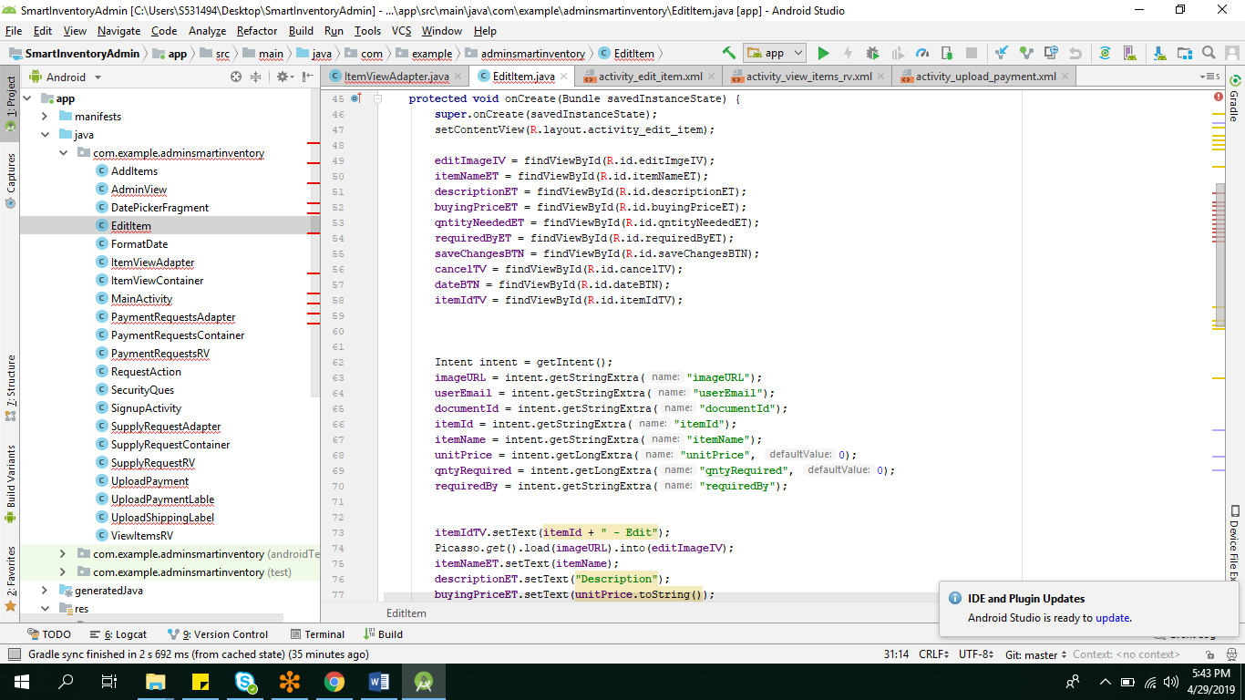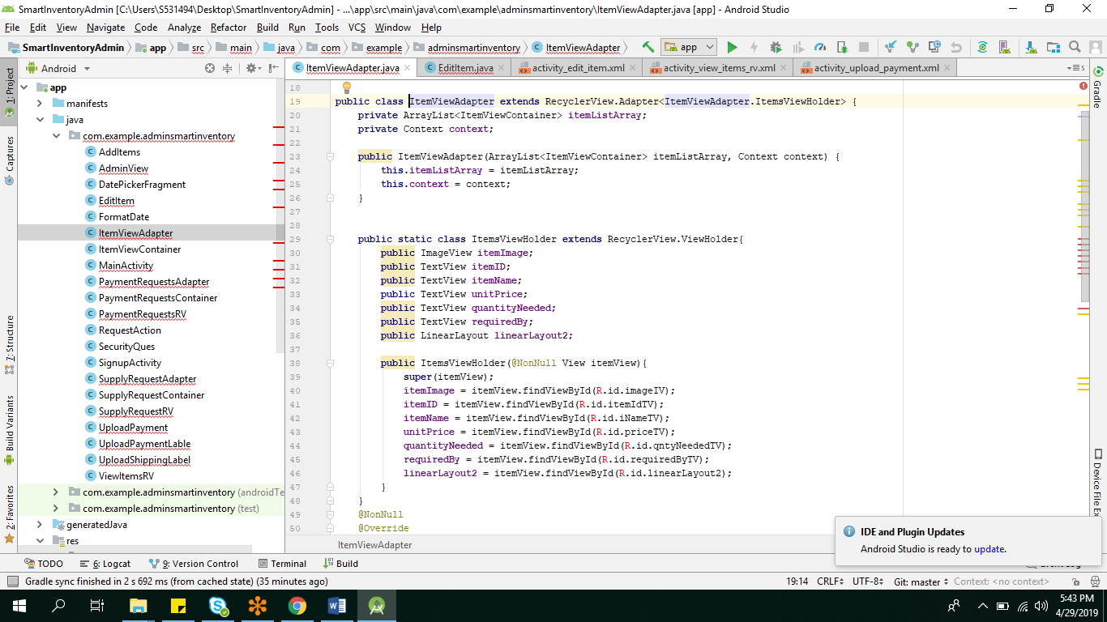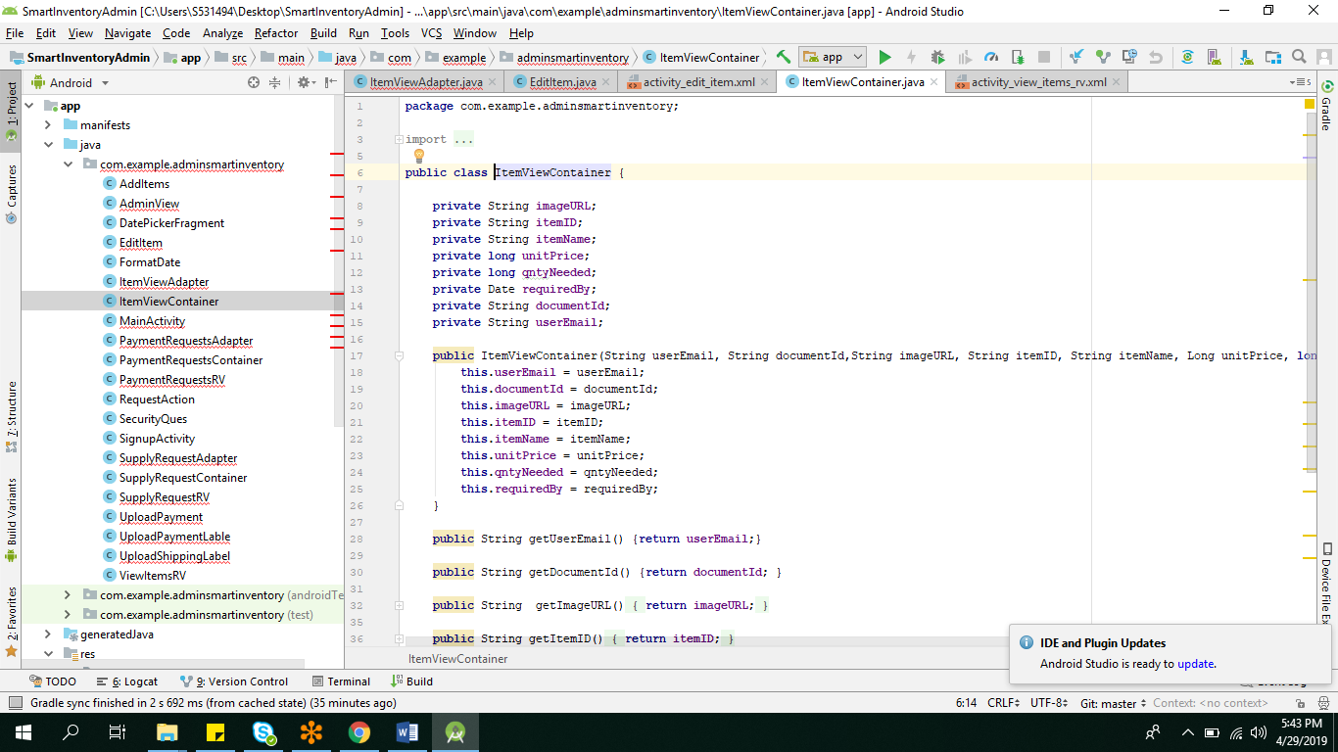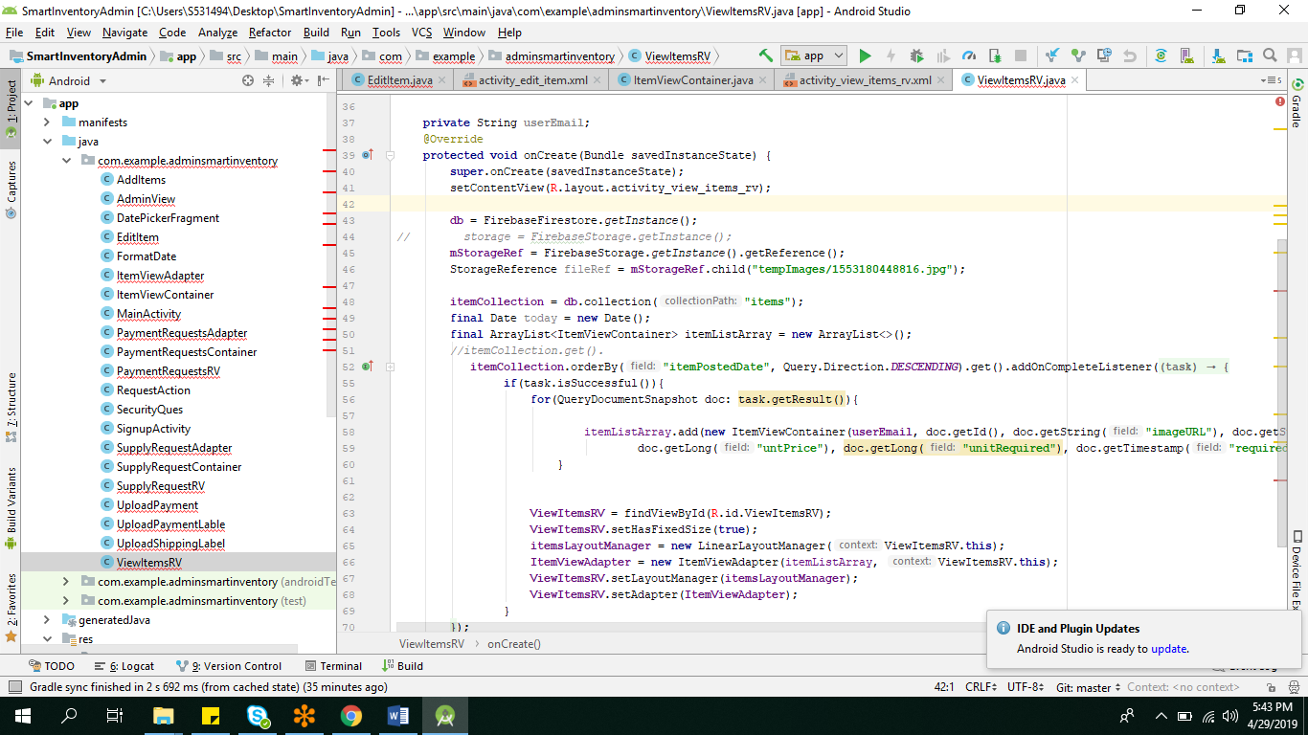

**Xml Functionalities:**

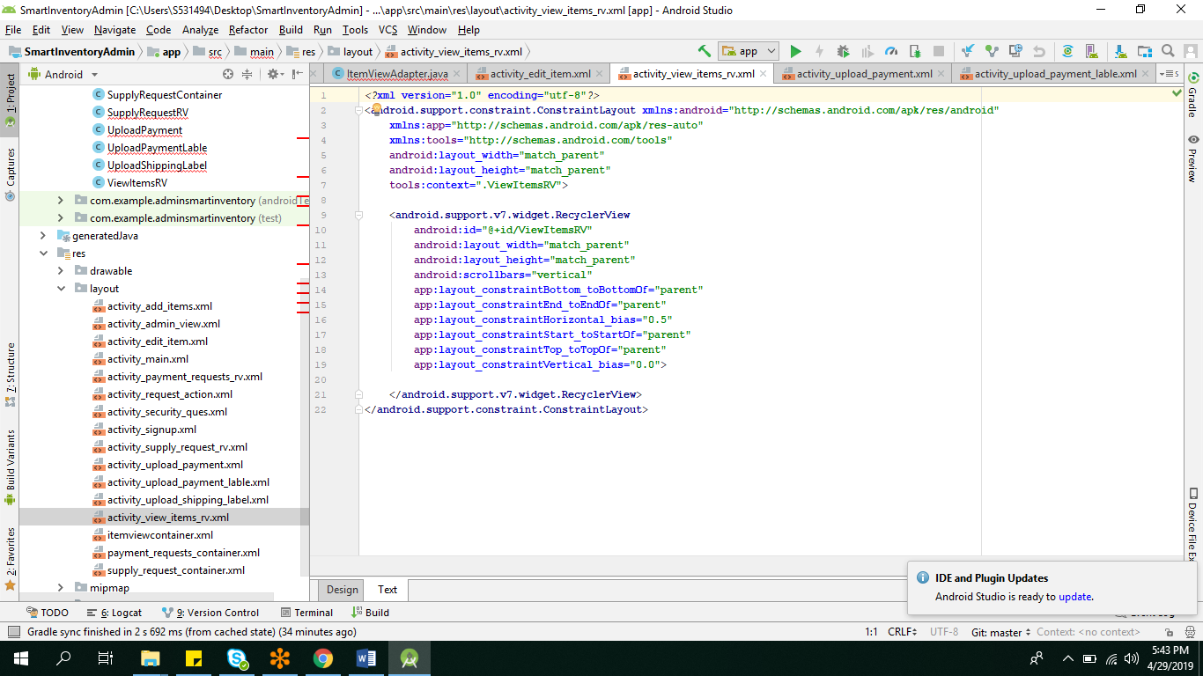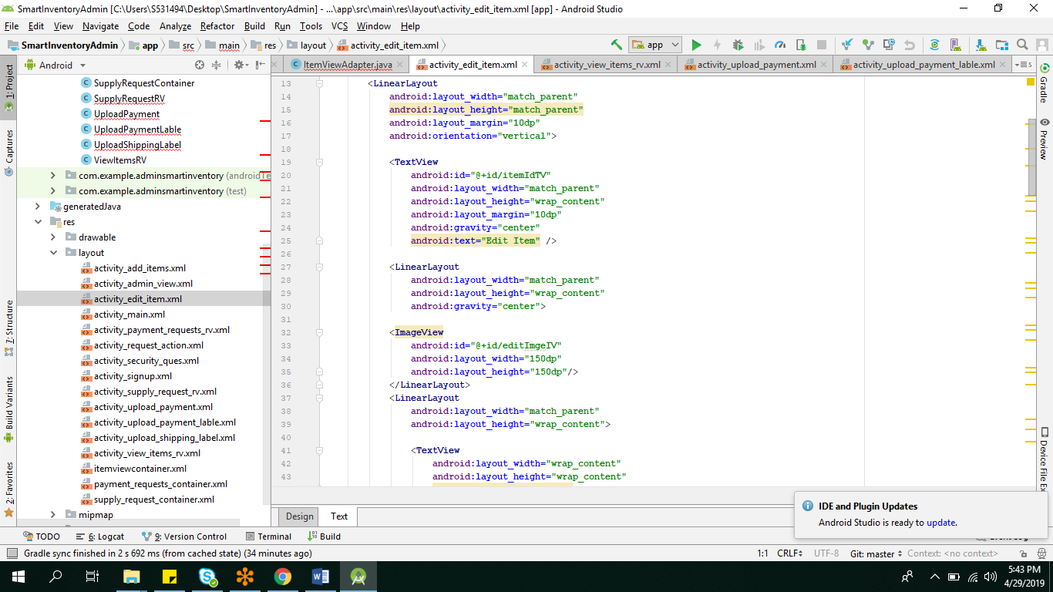

**Add item:**

**Admin can add item or post the announcement by filling all the fields and uploading the image as shown in the below two views.**

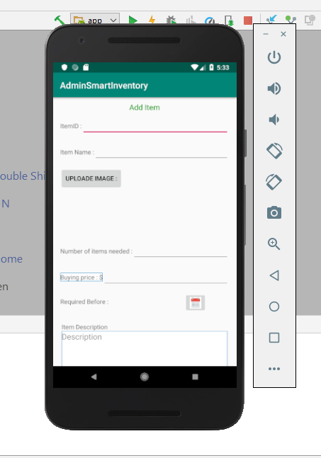

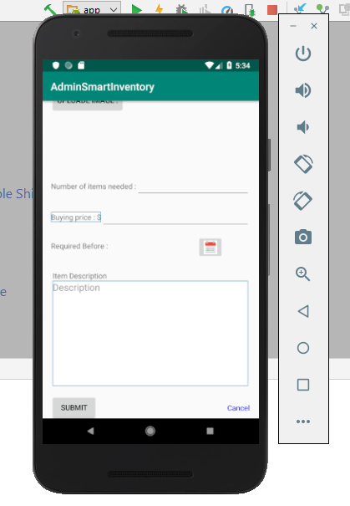

**Java class and Xml fucntionlity for the add item:**

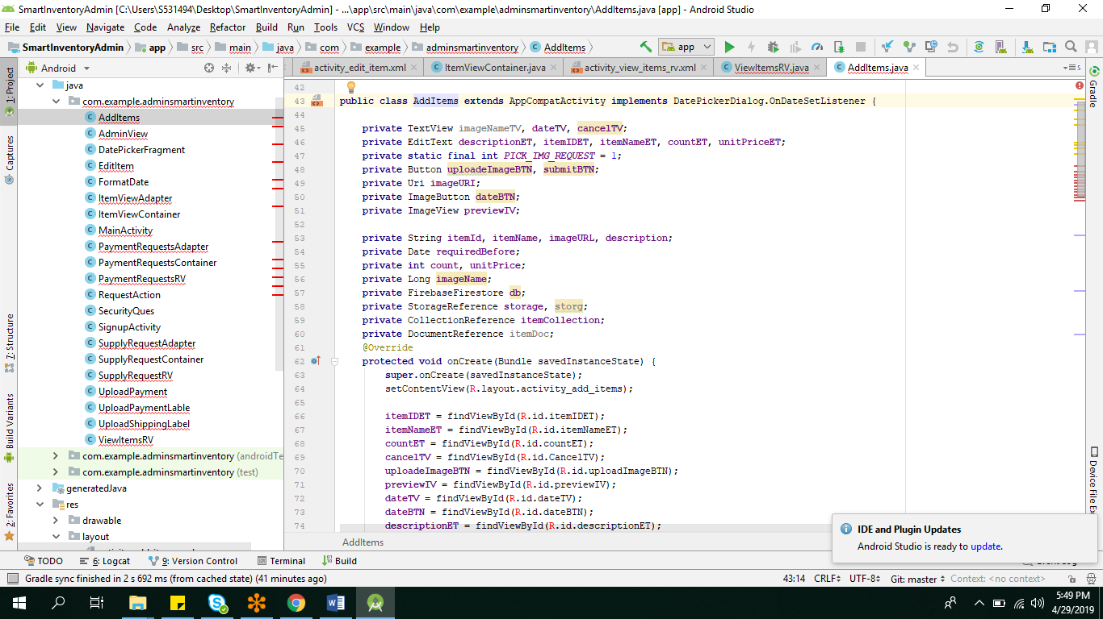

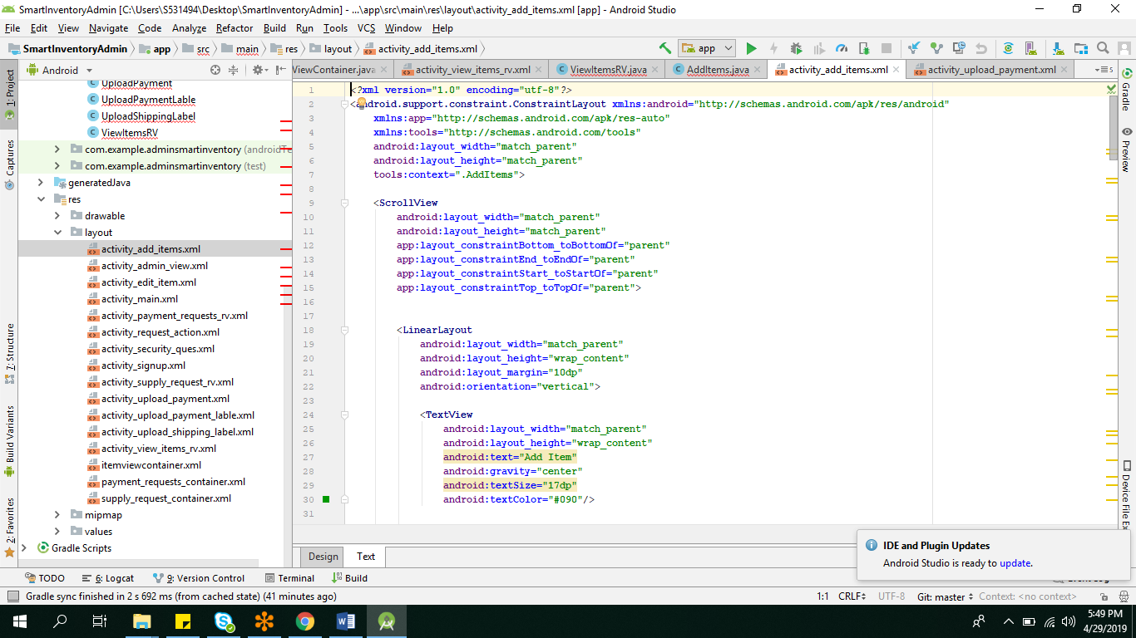

**Messages:**

**Admin can reply to the messages sent by the vendors and chat with the users for clarifying them.**

Smart Inventory - Android App

Version 1.0.0

# **End User’s Manual-Admin**

Client’s User Manual

Team : Android Team

Course: 44691-1

Class : GDP 02 Spring 2019

TEAM MEMBERS

Rakesh Varma Nadakudhiti

Snohitha Rakashi

Lokeswari Pittu

Nilantha Dambadeni Kalu Achchillage

Shivani Busireddy

Niharika Gundala

Karthik Raja Vemula

**USER’S MANUAL**

**TABLE OF CONTENTS**

1. General Information

2. Installation

3. Signup

4. Login

5. Password Recovery Steps

6. Logout

7.Security Questions

8.Post/Cancel Announcement

9.Approve/Deny User Supply Request

10.Record and Post Shipping Labels

11.Check and Confirm User supply Items

12.Make payments to user

## **1. General Information**

Smart Inventory-Android is an android based app that allows communication between vender (owner) and clients (users) for clients to supply vender required items to the vendor.

## **2. Installation**

Download the Admin app from online store, install it on your android device

## 

## **3. Signup**

- Use the signup link on the login page to sign up

- Provide valid email address as user name

- Provide a strong password, should have at least 6 characters

- Provide the personal information

- Click continue

- Select and answer two security questions

- Click signup button.

- User will receive a email asking for the email verification.

- Open the email and click on the link to verify the email address

- Go back to the app login page and use the email address and password to login to the app.

## **4. Login**

- Open the App and the first page is the login page

- Use the registered email address in the email field

- Use the registered password in the password field

- Click on the login, user will login into the system

- It will redirect to the list of the items page

## **5. Password Recovery Steps**

- On the Login page, click on the forgot password link

- Type the registered email address in the email field shown in the redirected page

- Click the send request

- It will send an reset password email to the Users email

- In the email, click on the link to reset the password

- It will redirect to the new page and user can give the new password :)

- And then click on Save for the password change.

- Last step is to login by using registered email and password.

## **6. Logout**

- Click on the more options on the action bar in any page, select the logout button

- User is successfully logged out

- It will redirect to the login page.

## **7.Security Questions**

- We need to give security questions once they are trying to signup for the account.

- We need to give 2 security questions and answer them for further usage.

## **8.Post/Cancel Announcement**

- Click on login as admin.

- The admin login will be redirected to the admin dashboard.

- You will find messages ,click on messages and admin can post announcement.

- If admin finds the announcement is not useful or admin wants to remove the announcement he can remove the announcement.

## **9.Approve/Deny user supply request**

- Click on login as admin

- when you are logged in as admin you will find buttons in dashboard and in dashboard you will find supply request button.

- After clicking the supply request button you will find Approve or deny supply request.

- Admin will find a supply request and admin need to either approve or deny the supply request which is requested by the user. Admin can add the items which are available.

- Then it will show whether it is approved or denyed.

## **10.Record and post shipping labels**

- After logging into the application we will find the payment button and after clicking into the button.

- After clicking the button they need to update the shipping labels.

- The admin can record the shipping labels.

- And also they can post the shipping labels which the user can see in the application.

## **11.Check and confirm User supply items.**

- After logging into the application the user requests the admin for the supply of items.

- The admin need to click on supply item button.

- After clicking on the button the admin need to check the items requested and need to confirm the user supply items.

- And then click on make hanges button to make all desired changes.

## **12.Make payments to User.**

- After logging in to the application admin dashboard appears.

- The admin needs to click on payments button and then the admin need to enter all card details.

- Needs to provide all card details and all required details for payment.

- The admin needs to enter the payment amount and can make payments to the user.

Smart Inventory - Android App

Version 2.0.0

# **End User’s Manual - User**

Client’s User Manual

Team : Android Team

Course: 44691-1

Class : GDP 02 Spring 2019

TEAM MEMBERS

Rakesh Varma Nadakudhiti

Snohitha Rakashi

Lokeswari Pittu

Nilantha Dambadeni Kalu Achchillage

Shivani Busireddy

Niharika Gundala

Karthik Raja Vemula

**USER’S MANUAL**

**TABLE OF CONTENTS**

1. General Information

2. Installation

3. Signup

4. Login

5. Password Recovery Steps

6. Logout

7. View list of required items

8. View item detail page and make a supply item request

9. View supply request history

10. Detail view of supply items requests and edit pending request functionality

11. About us

12. Contact page

13. Download shipping label functionality

14. Send payment requests

15. User reply page

## **1. General Information**

Smart Inventory-Android is an android based app that allows communication between vender (owner) and clients (users) for clients to supply vender required items to the vendor.

## **2. Installation**

Download the client app from online store, install it on your android device

## **3. Signup**

- Use the signup link on the login page to sign up

- Provide valid email address as user name

- Provide a strong password, should have at least 6 characters

- Provide the personal information

- Click continue

- Select and answer two security questions

- Click signup button.

- User will receive a email asking for the email verification.

- Open the email and click on the link to verify the email address

- Go back to the app login page and use the email address and password to login to the app.

## **4. Login**

- Open the App and the first page is the login page

- Use the registered email address in the email field

- Use the registered password in the password field

- Click on the login, user will login into the system

- It will redirect to the list of the items page

## **5. Password Recovery Steps**

- On the Login page, click on the forgot password link

- Type the registered email address in the email field shown in the redirected page

- Click the send request

- It will send an reset password email to the Users email

- In the email, click on the link to reset the password

- It will redirect to the new page and user can give the new password :)

- And then click on Save for the password change.

- Last step is to login by using registered email and password.

## **6. Logout**

- Click on the more options on the action bar in any page, select the logout button

- User is successfully logged out

- It will redirect to the login page.

**7. View List of Item View**

- After login in with the credentials, the page pops-up is the item view.

- It gives a list of items with their image and with minimum detail.

**8. View Item detail page and make a supply item request**

- After viewing item list view, you can click on the desired item to get the detailed view.

- Which show the item description and number of items you wish to supply.

- An optional message block gives you to give details on the request.

- Click the submit request button to send the desired request to the admin.

**9. View supply request history**

- Click on the more options on the action bar in any page, select the supply request history button.

- You could see the list of requested items with the date and the quantity you have requested.

**10. Detail view of supply items requests and edit pending request functionality**

- After getting the list view of supply history items, click on the desired item you want to edit or get the detailed view.

- You can edit the number of requested items and click the submit button to give the new updated amount.

- You can even delete the request by clicking on delete my request.

**11. About us**

- Click on the more options on the action bar in any page, select the about us option.

- You could see the brief description of the application.

**12. Contact page**

- Click on the more options on the action bar in any page, select the Contact us button.

- You would be redirected to a page with the two text fields to enter title and the message you wish to send the admin.

- Click the submit button to send.

**13. Download shipping label functionality**

- After your request is approved you can check the status by going to the supply history page.

- If the status shows approved, you can click on the item and you could find an option saying to download the shipping label.

**14. Send payment requests**

- After the items received by the admin and the status showing delivered.

- You can click on the item and can find the payment request.

- You can find the details to be entered like the bank account details.

- Click the send request button whenever you are done.

**15. User reply page**

- Click on the more options on the action bar in any page, select the User reply button.

- You can see the messages you have sent to the admin in the contact us page in a list with the date created.

- You can send the reply message if the admin sends you a reply by clicking the message.

- Here you can find the message template and click a button to send the message which hen updates the list of user reply page and redirects to it showing the recent message.

Smart Inventory - Android App

Version 2.0.0

**Testing User and Admin functionalities**

Team : Android Team

Course: 44691-1

Class : GDP 02 Spring 2019

TEAM MEMBERS

Rakesh Varma Nadakudhiti

Snohitha Rakashi

Lokeswari Pittu

Nilantha Dambadeni Kalu Achchillage

Shivani Busireddy

Niharika Gundala

Karthik Raja Vemula

**AdminTest Cases:**

**Purpose and methodology**

|  |  |  |  |  |  |
| --- | --- | --- | --- | --- | --- |
| Functionality | Description | Input | Expected Output | Actual Output | Status |
| **Login**                                                        **Add Items**                                                                **Edit/Delete items** | Enter the admin name and password to get logged in.                                                        To add an item in inventory, admin should provide the following details:  ID, picture of the item, Item name,  Description,price, no. of units needed, added date, expiring date, comments.                                                To Edit/Delete an item, we first choose an item and edit the fields we want to change or delete the item. | AN: s528116@nwmissouri.edu  PW: 123456 | User dashboard | User dashboard | Passed |
| AN: s528116@nmissouri.edu  PW: adkenf | User dashboard | Login Failed. (Invalid Email ID)Remains on the same login page. | Failed |
| AN:  s531368@nwmissouri.edu  PW:  239 | Password should be at least 8 characters long. | Login Failed (Invalid Password) | Passed |
| AN:  abc@gmail.com | Should not log in as password field is empty. | Login Failed. | Passed |
| ID:1  Name: iPhone Xs  Upload image: iPhone.png  No. of items needed: 4  Price: $999  Required Before: 05/21/2019  Item Description: 16GB  Click on submit | When item is added and clicked on submit it should go to item list view. | It is redirected to item list view page and the updated item gets reflected. | Passed |
| ID:2  Name: iPhone 6  Upload image: iPhone6.png  No. of items needed: 10  Price: $799  Required Before: 07/10/2019  Click on cancel.  Item Description: 64GB | Redirect to admin dashboard | Getting redirected to dashboard | Passed |
| Item Name: BabySeat  Buying Price: $50  Quantity Needed: 10  Click on the button save changes.  Click on yes when an alert pops up. | Alert box confirming the changes and returning back to list of items page. | Alert box confirming the changes and returning back to list of items page. | Passed |
| Name: TV  Buying Price: $90  Quantity Needed: 5  Click on the button Cancel. | Should return back to list view of items. | Remains on the same page instead of going back to list view of items. | Failed |
| Name: BabySeat  Buying Price: $50  Quantity Needed: 10  Click on the button save changes. | Should return back to list view by not asking any confirmation. Since we have not changed anything. | Asks you whether you are sure to save changes. | Failed |
| **Supply Request** | All the supply request sent by the vendors are shown here. Admin can view all the requests and if he have any queries, he can send a message to the vendor. | Select the New Supply request :TV  Change status to: Approved.  Message:  Want more supplies.  Click on submit. | Go back to the supply request page and update the item in the page to “Approved”. | Pop-up window is displayed if you are sure to change the request to “Approved”  And then go back to the supply request updated page.. | Passed |
| Select the New Supply request :TV  Change status to: Denied.  Message:  Had some issues.  Click on submit. | Go back to the supply request page and update the item in the page to “Denied”. | Pop-up window is displayed if you are sure to change the request to “Denied”.  And then go back to the supply request updated page.. | Passed |
| Select the New Supply request :TV  Do not change anything and click on cancel. | Should go back to supply request page. | Cannot go back to supply request page. | Failed. |

**User application test cases**

|  |  |  |  |  |  |
| --- | --- | --- | --- | --- | --- |
| Functionality | Description | Input | Expected output | Actual output | Status |
| Login | Enter the user name and password to get logged in. | User name:s528116@nwmissouri.edu  PW: 123456 | Item List view | Item List view | Passed |
| User name: lucy99108@gmail.com  PW: 1234567 | Incorrect Password | Incorrect password | Passed |
| Registration | Enter the registration details to register | Email: poojithasingham@gmail.com  Password:Abc@123  Confirm Password: Abc@123  First name: Poojitha  Last name:Singham  Phone number:1234567890 | Security questions | Security questions | Passed |
| Email:lohithavarma03@gmail.com  Password:Abc@123  Confirm Password: Abc@124  First name: Lohitha  Last name: Bhethalem  Phone number:1234567890 | Password doesn’t match | Password doesn’t match | Passed |
| Answer the security questions to complete the registration | Birth city: Tirupathi  Favorite color: White | Email verification sent | Email verification sent | Passed |
| Birth city: Hyderabad  Favorite color: | Please answer both the questions | Please answer both the questions | Passed |
| User Supply Request | User can send the supply request to ad by clicking on the item | Select the item  Number of items you wish to supply: 5  Message: optional | Item should be shown in the supply history  Quantity needed:7  Items Supplied:5 | Item displayed in the supply history  Quantity needed:7  Items Supplied:5 | Passed |
| Editing supply request | User can change the amount of items before admin has approved the request | Go to supply history and click on the supplied item and change the amount and click on submit  Amount:4 | Required items :8  Items Supplied:4 | Required items :8  Items Supplied:4 | Passed |
| Dekte  Supply request | User can delete the item before admin has approved the request | Go to supply history and click on the supplied item and click on delete request | It must be delete the item from Supply history and  Quantity needed must be 12 | Item has been deleted from the list and Quantity needed is 12 | Passed |
| About | User can know the information regarding the application | Go to vertical ellipsis or 3 vertical dots and select about | Information about the application have to be displayed | Information regarding application is displayed | Passed |
| Contact us | User can contact the admin | Go to vertical ellipsis or 3 vertical dots and select contact us  Title:iphone 6  Message: I have more items  Click on submit | Message has to be displayed in the messages which indicates that message has been sent to admin | Message is displayed in messages |  |
| Log out | User can log out from the application | Go to vertical ellipsis or 3 vertical dots and select log out | Must display the login page of application | Login page of the application is displayed | Passed |